All intramural participants will be required to create an account on IMLeagues.com.

***IMLeagues now has a mobile app (called IMLeagues) that can be downloaded for free from the App Store and Google Play Store! It can be used to signup and create/join teams!!!!!!

To create an IMLeagues account: **Note** IMLeagues offers a live support button in the bottom right corner of all pages, please use this button if you encounter any difficulties.

- Go to www.imleagues.com/FSU/Registration
OR
Go to www.imleagues.com and click SIGN UP
OR
Go to www.imleagues.com and click “Log in with Facebook” if you have a facebook account with your school email attached - this will automatically create an account, fill in your info, and join you to the school (steps 2-4)

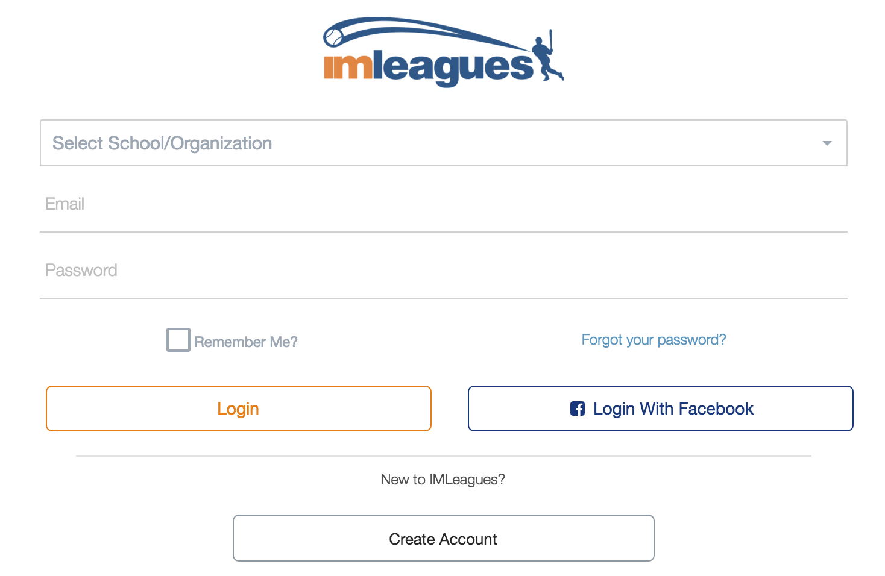

- Enter your information, and use your School email if applicable (@fsu.edu) and submit.

- You will be sent an activation email, click the link in the email to login and activate your IMLeagues account.

- You should be automatically joined to your school – If not you can search schools by clicking the “Schools” link

How to sign up for an intramural sport:

- Log in to your IMLeagues.com account.

- Click the “Get Involved” button at the top right of your User Homepage page
OR
Click on the “Florida State University” link at the top to go to your school’s homepage on IMLeagues.

- The current sports will be displayed, click on the sport you wish to join.

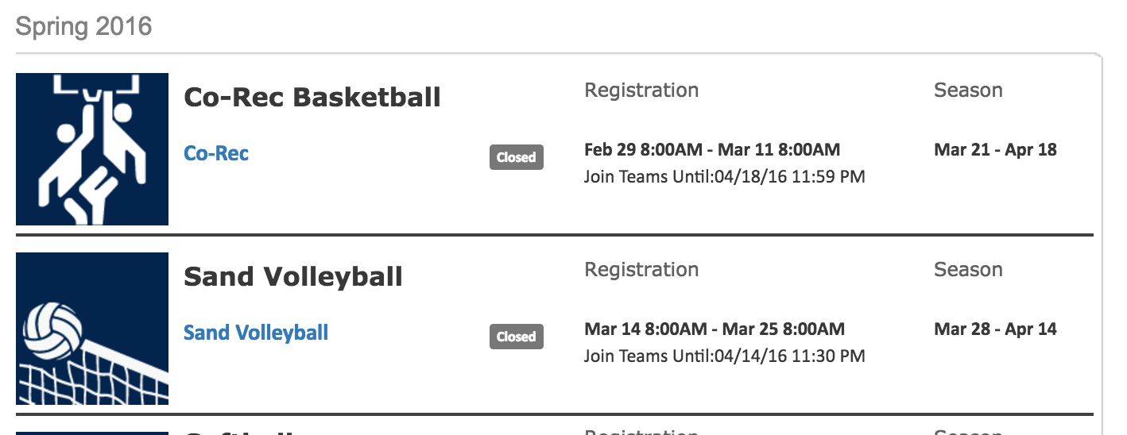

-Choose the league you wish to play in (Men’s, Women’s, Co-Rec, etc.)

- Choose the division you’d like to play in (Monday 5PM, Tuesday 5PM, etc.)

- You can join the sport one of three ways:
  - Create a team (For team captains)
    - Captains can invite members to their team by clicking “Team Options” and then “Invite Members” link on the team page. Any invited members must accept the invitation to be joined to your team.
      - If they’ve already registered on IMLeagues: search for their name, and invite them
      - If they haven’t yet registered on IMLeagues: scroll down to the “Invite by Email Address” box, and input their email address.
  - Join a team
    - Find existing teams on the league page and click the “join team” button to send a request to join a team
    - Accepting a request from the captain to join a team
    - Finding the team and captain name on division/league page and requesting to join
    - Going to the captain’s playercard page, viewing the team, and requesting to join
  - Join as a Free Agent
    - You can list yourself as a free agent in as many divisions within a league as you’d like. You will be visible to all members of the site and can request to join teams, or post information about yourself so teams can request to add you to their team.

