How to Create or Join a Team (for participants)
- Log in to your IMLeagues.com account.

Click on to “______ College/University” link to go to your school’s homepage on IMLeagues:
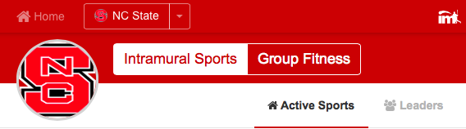
- The current sports will be displayed, click on the sport you wish to join (ex. Basketball).
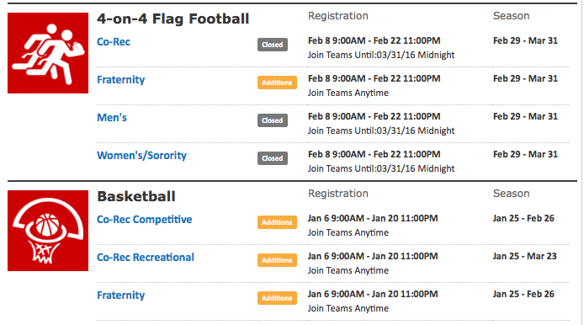

- Choose the league/division you wish to play in (Men’s, Women’s, Co-Rec, etc.)
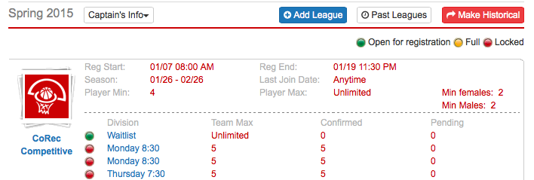

- You can join the sport one of three ways by clicking the green “Register/Signup” button located here:

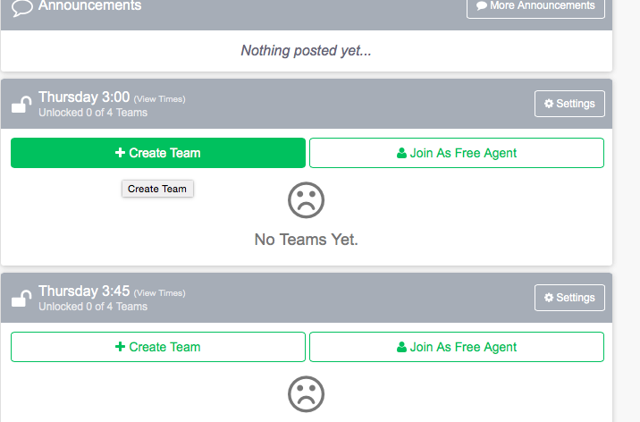

  - Create a team (For team captains)
    - Click on the green “Register/Sign-Up” button, then click “Create A Team”, and you will be brought to a page that looks like this:
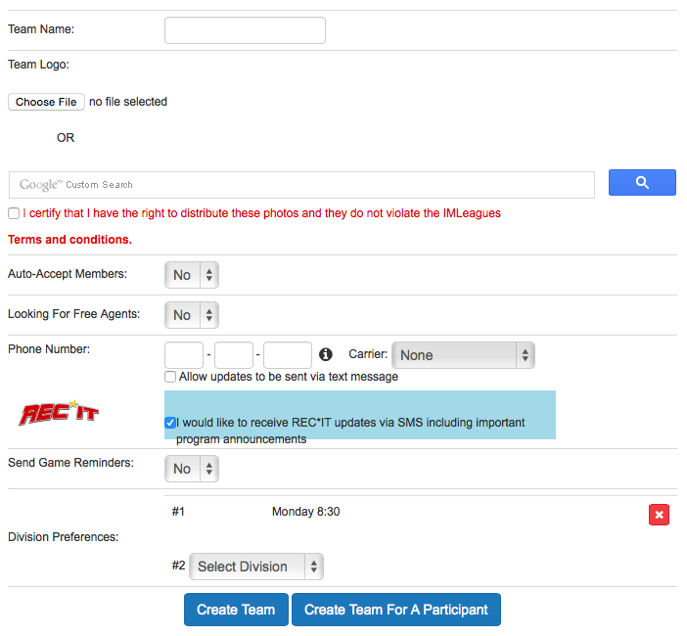

- At the top is a box which contains your school’s waiver and/or registration policies and procedures. You must read and scroll down to the bottom of this box and then hit the “Accept” button. Then you must also check the box that says “By checking this box I indicate I have read, understand, acknowledge and accept the above Waiver/Agreement”
- Next you can enter your team’s name and logo (make sure if you upload a photo that you click the box saying you have the rights to publish the photo)
- Auto accept members: this function will allow people to sign-up on your team without your direct approval (it is a personal preference)
- Team status: this can be set as “not looking” or “looking” for players based on whether or not you want free agents to see that you might be willing to pick them up.
- Related Group: this allows you to identify whether or not your team should be identified with a specific group that has been set up (i.e. fraternities, sororities, clubs, etc.) - not all school’s use this function

To complete your sign-up don’t forget to hit the Create Team button at the bottom of the page!
    - Captains can invite members to their team by clicking the “Invite Members” link on the team page:
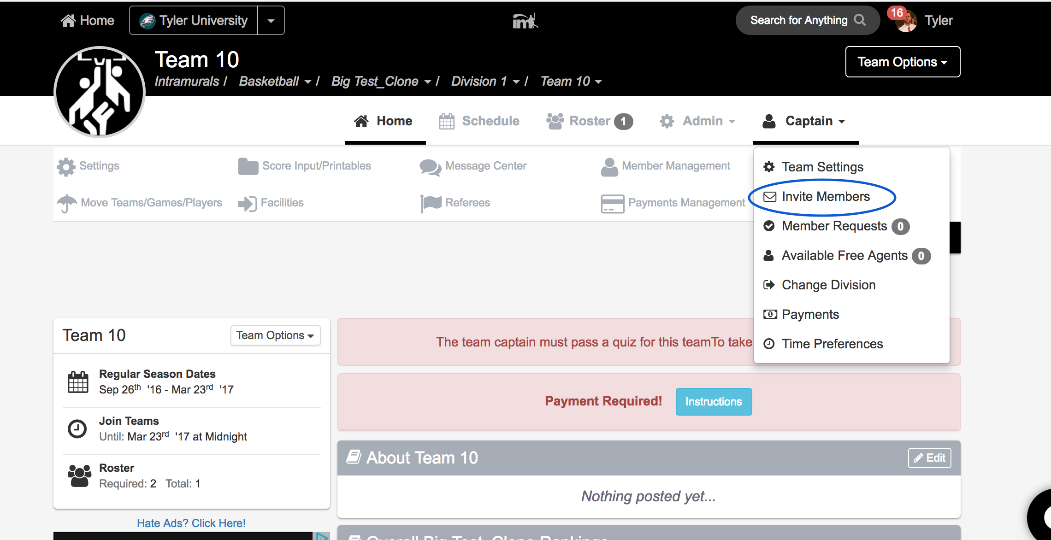

(next to this area you can also choose to customize your team’s page with colors, logos, etc!)

    - Any invited members must accept the invitation to be joined to your team.
      - If they’ve already registered on IMLeagues: search for their name, and invite them
      - If they haven’t yet registered on IMLeagues: scroll down to the “Invite by Email Address” box, and input their email address.

  - Join a team
    - Use the Player Sign-up drop-down menu at top right of every page and click “join team” – find the team you wish to join (make sure to look under the right sport and league) and click on the “join team” button.
OR
    - Accept a request from the captain to join a team (this request will pop up like a facebook notification in the top left area of your screen)
OR
    - Finding the team and captain name on division/league page and requesting to join
OR
    - Going to the captain’s playercard page, viewing the team, and requesting to join (you can do this by searching the team captain’s name in the search box at the top of your screen)

  - Join as a Free Agent
    - You can list yourself as a free agent in as many divisions within a league as you’d like (again use the Player-Sign up drop-down menu on the top right of every page). You will be visible to all members of the site and can request to join teams, or post information about yourself so teams can request to add you to their team.

