IMLeagues Basic Set-up Instructions
*This is a basic guide on how to start up your school’s IMLeagues page. For further information, if you need it, please schedule a set-up call with us or ask us for more detailed instruction manuals
Once you login to your IMLeagues Admin account click on your school’s tab at the top of the page
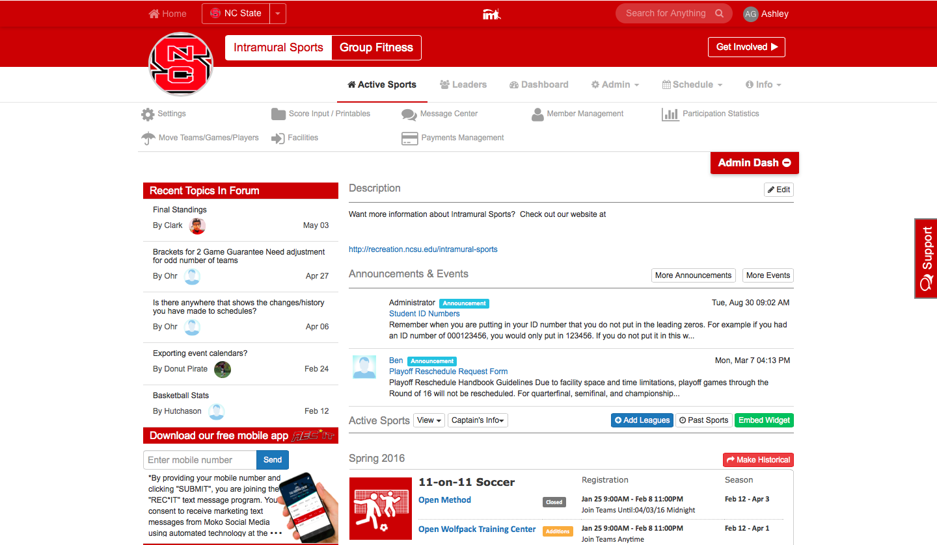
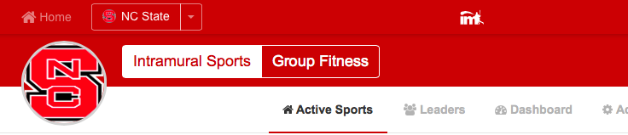
Clicking your school’s name or its logo will both take you to the homepage
This will bring you to your school’s homepage which
shows things such as school description, school
announcements, school events, as well as all of the
sports offered during the current season. An already
set-up school will look similar to the one shown

- To change any of this information click on the
“Edit”, “Add new”, or “Compose/More” buttons
Now you need to do the following:
- Define your School and Intramural Settings. Hover over the “Admin” icon
and click on the “Network Settings” link on the top white bar of the
page. From here you can set your school specifics and upload
waivers. “Intramural settings” will also be right under “Network Settings” under the Admin icon and there you can also upload a wavier, change the intramural tab name for your school, change the ref settings, and change other options for your sports and general intramural settings.
- Set-up your Facilities. Hover over the “Schedules” box on the left hand side of the page and click on the “Facilities” link. Click “Add New” and enter the name, address (find it on the Google Map!) and surfaces used in this facility. Note: A Facility must have at least 1 Surface – Games are scheduled on surfaces.
- Set-up a Sport and Leagues. At the bottom of your school’s homepage click on the “Add Leagues” button. From here use the buttons and drop down menus to choose your new sport and to input your sport details (icons, joining restrictions, game length, facilities used, etc.). Also notice the Captain’s Quizzes tab at the top of this area! In order for a sport to be active, and show up on the main homepage, it must have active leagues within it. Once your sport is created it will automatically go into the league settings to create your league. From here you can set-up your season, the min/max player number requirements, registration dates, dates of your regular season, and other league specific details. *once you make one league it is easy to transfer your information to another league by clicking using the “Fill In Settings From” tool at the top of the league create page for when you re-run the sport.
  - Set-up your Divisions (not all school’s use this) (make sure you defined in your sport settings whether or not teams are created at the league or division level). Once inside the league click on “Add Division” and go through the steps to get it set-up.

Remember: the program hierarchy goes SCHOOLSPORTLEAGUEDIVISION. You can access all necessary admin links using either the dashboard area at the top of your pages or from your school’s IMLeagues homepage.

