Setting-up a “New Season” with IMLeagues
*Time marches on and now you need to get ready for another semester full of Intramural Sports and here is how to get started! Don’t worry, this type of set-up is much faster and easier than when you were initially setting-up your school.

- Once you have created a sport for one season you never have to recreate that sport again. Imagine an umbrella – this would be your sport – and within this umbrella you have your leagues within seasons (and then your divisions if necessary). To reactivate the sport all you have to do is add new active leagues.
- To do this:
- Click “Add Leagues” on your school page.
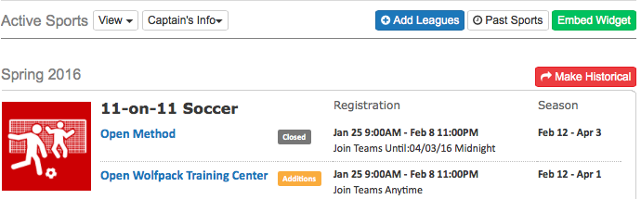
- You will be taken to create sport/league page next. If you just want to rerun a singular sport with a new league/season you can select it in the drop down box. A new feature that we added though is the Copy Past Season, Sport, or League option, where you can clone an entire season at once! Clicking on the season you want to recreate will give you ALL of the sports played, and then you can select what you’d like to re-activate. (Both options are indicated by the blue arrows below.)
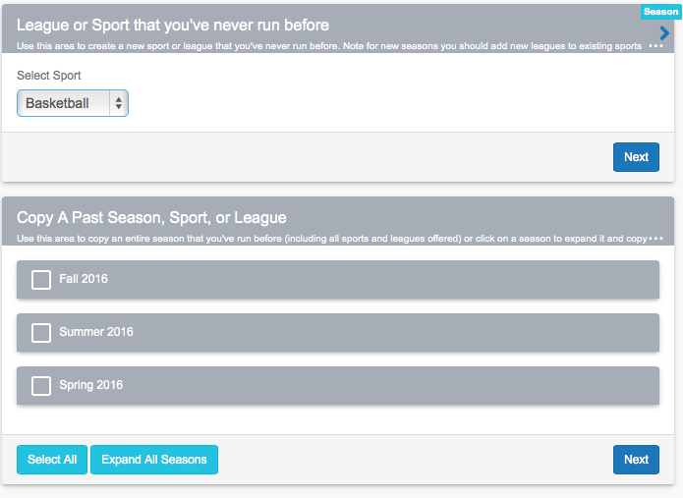

- When you decide to copy a whole season you will be given the option to set the season and year for when this new season of sports will take place for you (Ex: Spring 2017). Then click which sports you want to include by checking or unchecking the check boxes on the left hand side. Notice we also have a “Batch Edit” option that allows you to apply the same registration and regular season dates to multiple sports/leagues at once. This is a great time saver!
- Then click the “Clone” button and those leagues will be recreated. You will be asked which sport you want to go to first and from there you can go in and make any tweaks you would like to the new season or you can return to your school page. Note: The new season will have the same settings as the old one you clone, so always check your settings to make sure that is what you want again.

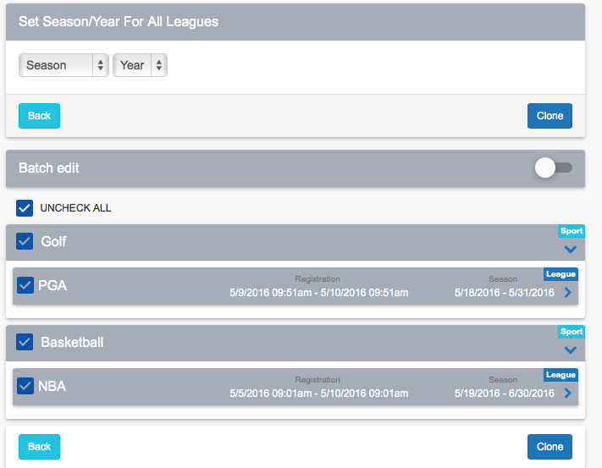

(If you choose to do only one sport at a time, follow this below)

If you were to just choose the sport you wanted to create a new season for and hit next from step 2 you will be brought to the league creation page. From there you should see two great time saving tools at the top: “Fill in Settings From” and “Clone League”.
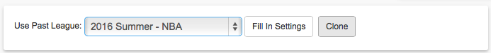

Fill in Settings From: this will allow you to fill in settings from another league you have already made in your current season – all you have to change is the league name (Men’s, Women’s, etc.) and make sure the season is correct.
Clone League: this will allow you to take a league from a previous season and fill in the settings from that. It will also try and guess your new registration dates (i.e. if you started your football league on the second Monday of October 2011 it is going to redo those dates to start on the second Monday of October 2012)

- Once your new leagues have been created the sport will show back up on your school’s homepage in the active sports area and you should be all set for your new year to begin!

