How to Set-up Your School
1. Log in to your IMLeagues account
2. Find your school’s tab along the top bar and click.
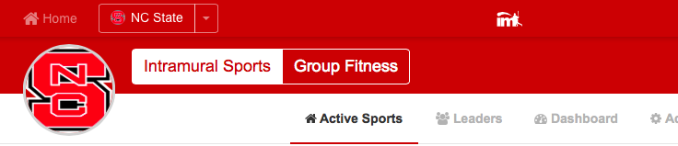
This will bring you to your school’s homepage which shows things such a school description, school announcements, school events, as well as all of the sports offered during the current season. A set-up school will look similar to the one shown below:

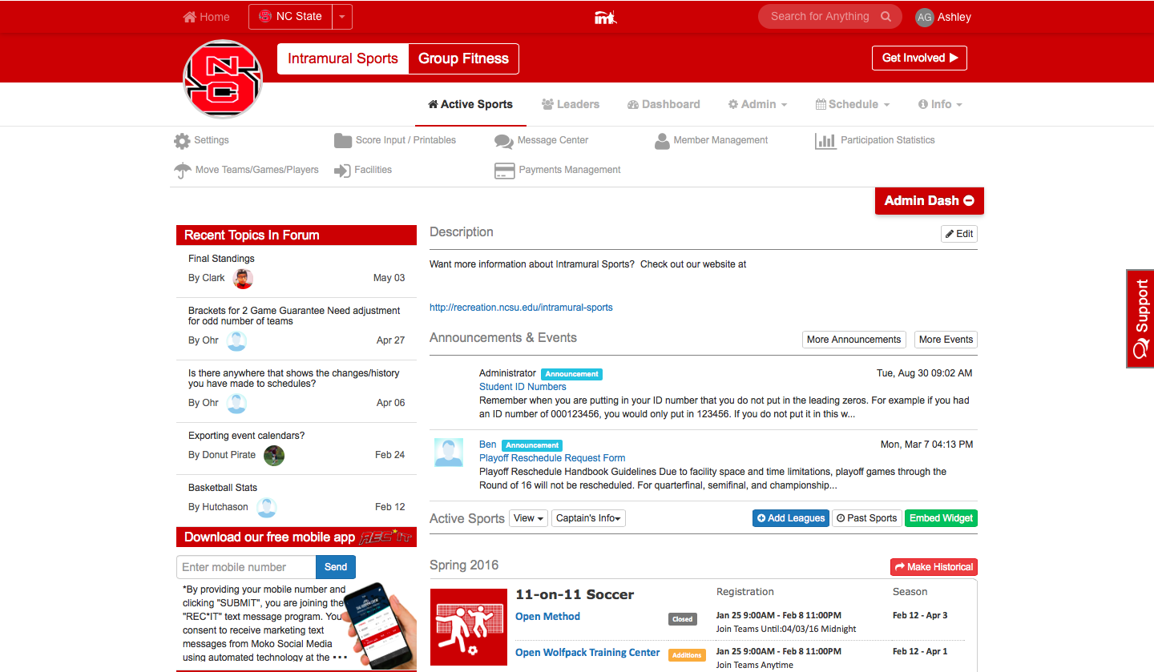

Setting up a school description is fairly straight forward – click on the edit tab and you will be brought to a page which shows a box in which you can input text, pictures, and even imbed videos. To set up an announcement click on “More Announcements” and you see a “add announcement” link. On the next page you will have the following options to choose from regarding your announcement and who the announcement should be sent to:
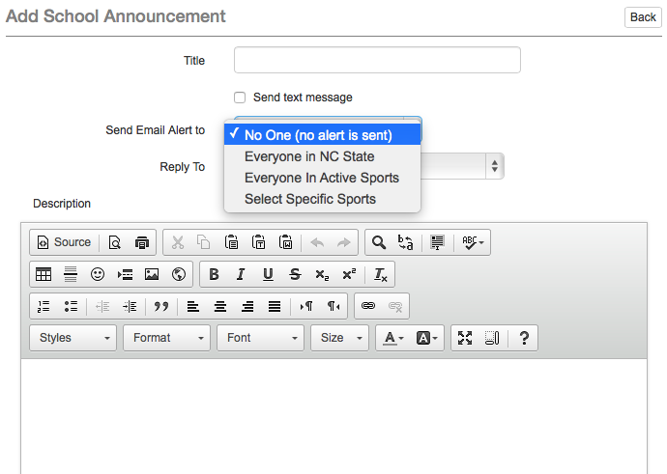

3. How to set-up more important school details.
- Hover over the “Admin” box and click on “Network Settings” on the top white bar(see red arrow below!) and you will be taken to your Main School Settings page.

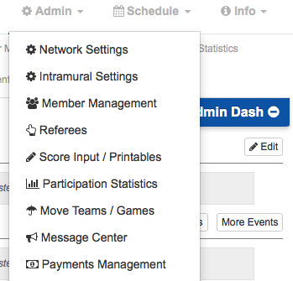

Now we will go through each aspect of the Main School Settings and what they mean:
- Network ID: this is your unique identifier in your public school URL which can be shared with participants so that they are directed straight to your own school’s page. Also, this will be used for your registration URL so that students can just use this link to sign up for sports.
- Network Type: this can be set-up as either public or private – but does NOT mean whether your school is a public or private institution. Public would mean that you are allowing people in the community to join your programs, private would mean that you are only allowing internal users in your programs.
  - If you set-up as private only those users who register with your specific domains (i.e. @yourschool.edu or @mail.yourschool.edu) will be allowed to enter your school’s IMLeagues page. To set up your domains type them in below in the school domains area and click add – you can add as many domains as you need.
  - Also under the school type selection box you will see 5 options that you can check off in the Publicly Viewable Area: Home Page, Sports Page, League Page, Division Page, and Team Page. You can choose, based on your school’s privacy needs, which pages you would like to be available for the public to be able to view.
- Receive Flagged User Reports: in 5 years of being in business IMLeagues has not had a legitimate flagged user report so this area should not be of much concern but the function is there just in case.
- Contact Information: this is more for the IMLeagues staff in case a student calls us and needs to get in touch with the admins at your school in the event where we cannot answer their question (i.e. when it is a school specific question rather than an IMLeauges program question)
- Payment Instructions: in this box you can enter any instructions for students who need to submit payments (i.e. “Please bring your payment for participation in IM Sports to the Campus Recreation Office by the close of registration”)
4. Check out the many different options across the top of the Network Settings Page including the ability to use a Waiver, customize the Registration Page, Connecting your IMLeagues page with Social Media, and the ID Sheet to choose whether or not to require a Student ID with Registration.

