How to Set-up Your School – Part 2
1. Log in to your IMLeagues account
2. Find your school’s tab along the top bar and click.
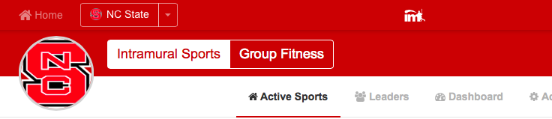

3. How to set-up other school details.
- Hover over the “Admin” box and click on “Network Settings” on the top white bar (see red arrow below!) and you will be taken to your Main School Settings page. From there click on the tab called “School Details”

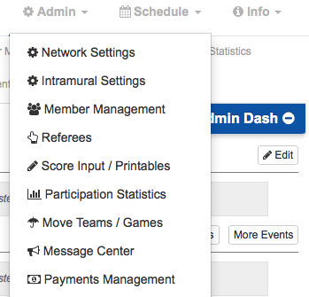

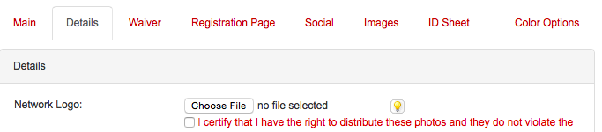

Now we will go through each aspect of the Details (See Blue Arrow!) and what they mean (some of it may already be completed by the IMLeagues staff when they were building your page but you can double check and change anything if you like):
- Network Logo: you can choose a file here (just check that you have the rights to it) and it will upload
- Network Banner: (this will be done by the IMLeagues staff so don’t worry about it!)
- Network Enrollment: input the number of students you have at your school
- Network Address: input the address of your school in the given lines below
- Time Zone: this is critical! Because it will affect the times used in your registration processes.
- Telephone: usually used for your front desk or main office number
- All accounts default to private: this sets the program up so that all participant accounts are private and cannot be used by other viewers (not usually necessary)
- Links: these refer to the links to the left of your screen (Hover over the “info” box to see the links) and can be changed to whatever type of terminology you would like to use:
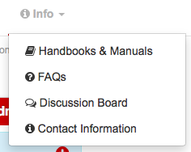

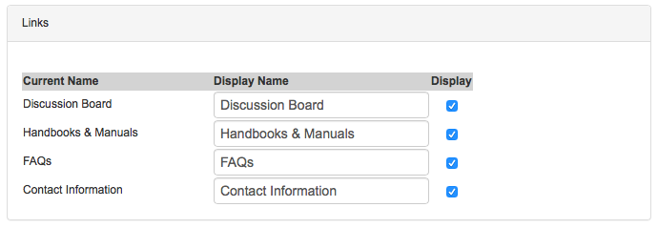

- Link to another Network: this area has become almost obsolete because of our NEW Club Sports features so just ignore it.
- Enable Fitness Component & Enable Club: these two areas are NEW and will enable these functions of IMLeagues for your programming purposes. For more specific information about these areas, if you are interested, please contact us at the office and we can do a separate walkthrough with you.
- Network Description: this will show you what you have on your school’s main page and can also be edited from their simply by clicking “edit”

Click submit and now you have completed your Network Details area!

