How to Set-up Your School – Part 3 (Waiver, Registration Page and ID Sheet)
1. Log in to your IMLeagues account
2. Find your school’s tab along the top bar and click.
3. How to set-up other school details.
- Click on “Network Settings” on the top white bar (see red arrow below!) and you will be taken to your Main Network Settings page. From there click on the tab called “Waiver” (see other red arrow pointing up!)
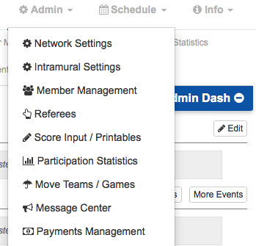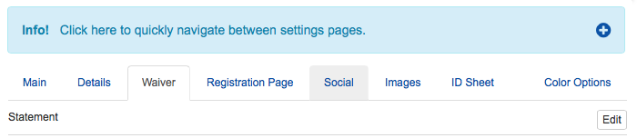

The Waiver area is pretty important and we have worked to make some great changes recently that will be able to help your program out!
- In the waiver area you have the option to edit or upload a waiver.
- You can also choose to store the IP address of whoever is signing the Waiver by clicking the little check box and this will give you the date and time as well as a record of the exact waiver the participant has signed. (To get to this information you need to search the person in the Member Management area, click on them, and you will see a button that says “signed waivers”)
- You can also add a question in the wavier (ex. you want them to have to type their name in on the waiver) by clicking on the little green “+”

4.How to setup Registration Page
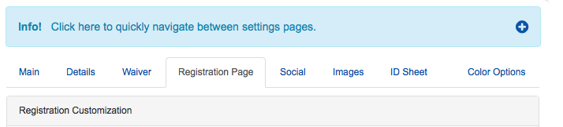

- Customize Registration Page: if you enable this function you can personalize what type of information you want collected from your participants based on their classification. You can easily change the names of these classifications (i.e. from “Freshman” to “Year 1”). You can also disable classifications if you do not want people to fall into that category (just unclick the check mark). Underneath you can include any other necessary registration information you want by typing in the given box.
- Custom Registration Questions: Allows you to add registration questions by clicking Add Question while offering a Text option if you want participants to type in their own response and a DropDown option if you want participants to select from multiple choice style responses.
- Don’t collect Birthday/Month: by checking this box you are only requiring that participants give you their birth year when registering.
- Registration Information: Allows you to type in any additional information that you want participants to see during Registration.

5. How to set up ID Sheet page
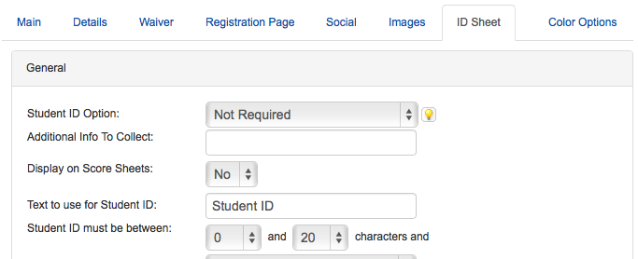

- Student ID Option: if you require a student ID from participants mark required from the drop down box
- Additional Info to Collect: when registering on the site users will have to enter whatever you ask them for in this area. Some schools use it to gather information on which residence halls participants live in, ethnicity, etc. This can be displayed on scoresheets if you wish.
- Text to use for Student ID: many schools keep this as “Student ID” but other schools customize it based on their own terminology (for example: Banner ID #)
- Student ID Must be Between: select the correct number of characters students must input for a valid student ID number. Below this a drop down box gives you the options of any characters, numbers only, and letters only – pick whichever style your school uses
- Extra Student ID Info: you do not necessarily have to use this unless you want some other type of identification from your students
- Always require Student ID information: meaning whether or not you want the participant to have to input their ID number every time they register.

