How to Set-up Facilities
- Login to your imleagues.com account
- Go to your school’s homepage
- Hover over the “Schedules” box on the top white bar and click on “Facilities”
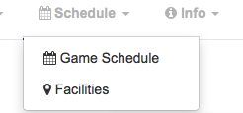

- Click on “Add New Facility” at the top right
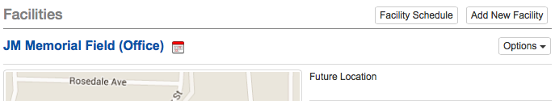
- You will be taken to a new page where you can enter your facility name and location. The location will then be located on the Google map. This is a great function so that participants know where to come for games and also for visitors to your campus.
- You can also add a description of the facility (i.e. turf vs. grass, what is not permitted on the site, etc.)
- Finally click Save Changes and this will create your facility and bring you back to the main facility page.
- Once you are back on the facility page make sure to add surfaces by click on the Add Surface
  - Name them whatever you wish (i.e. Field 1, Field 2, etc.). These surfaces will be used when you run the scheduler function and will determine how many games you can have running at the same time at each facility.
NOTE: make sure to add all of your school’s facilities (i.e. pools, tennis courts, fields, gyms, etc.)

