How to Set-up a Sport (with Leagues)
- Login to your imleagues.com account
- Go to your school’s homepage
- Scroll down to the sport area and click on add leagues:
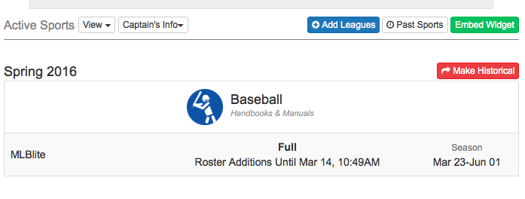

- This will bring you to a League/ Sport creation page that looks like this:

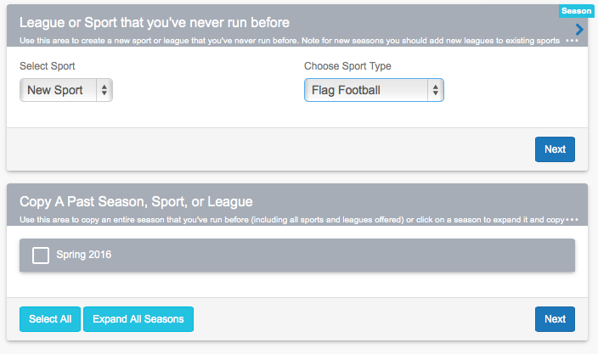
- Hit next once you selected your sport type. You also have the option to clone a sport as shown in the box below.
- Once you do that you will be taken to the Sports Settings page shown below:
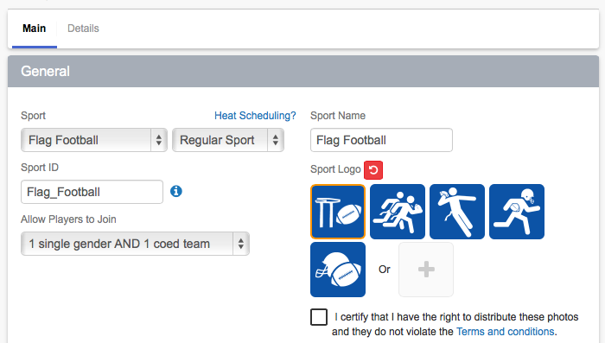

- Choose from the drop-down menu which sport you would like to set-up. Most sport templates have already been created in the program but should you find that the sport you wish to create does not exist, choose “other”
  - The sport name and sport ID boxes should automatically populate and give you a public sport URL
- Input a logo for the sport, you can also upload your own if you don’t like the standard ones that pop up
- Allow players to Join: choose either “1 single gender AND 1 coed team”, “1 single gender OR 1 coed team”, “one team in EVERY league”, or “one team in EVERY division) – this is based on your school’s participation restrictions.
- GAMES
  - Game length: use the drop-down menus to input how long your games last
  - Period name: (ie. half, quarter, etc.)
  - Period number: how many halves, quarters, etc. make up a game (ie. for halves it would be 2, for quarters it would be 4)
- SCORESHEETS
  - Scoresheet format: if you choose “use basic scoresheet” there are basic scoresheets already set-up for you based on the sport you have selected. If you choose “use custom scoresheet” you can create your own scoresheet (for more information about creating scoresheets please see instructions titled “Scoresheets”)
- STANDINGS
    - In this area you can set-up how you want your standings to be determined . Input your point values in the available boxes and use the drop down menus to choose from the options given to set-up how your standings will be determined based on game outcomes.

- Click submit and your sport will be created! You will be brought to a page to then set up your league settings that looks like this:

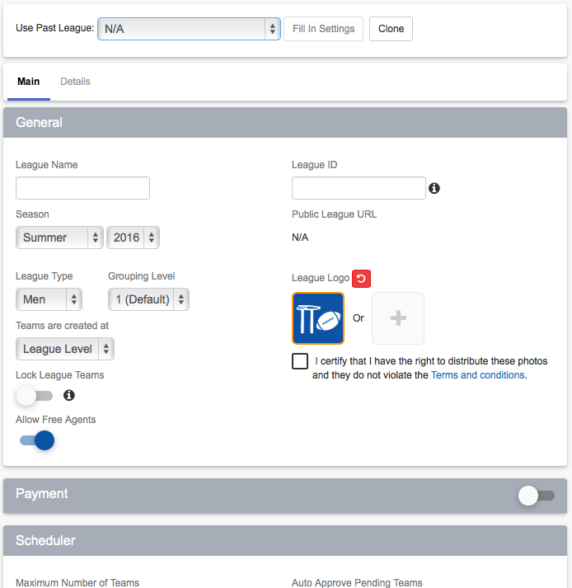

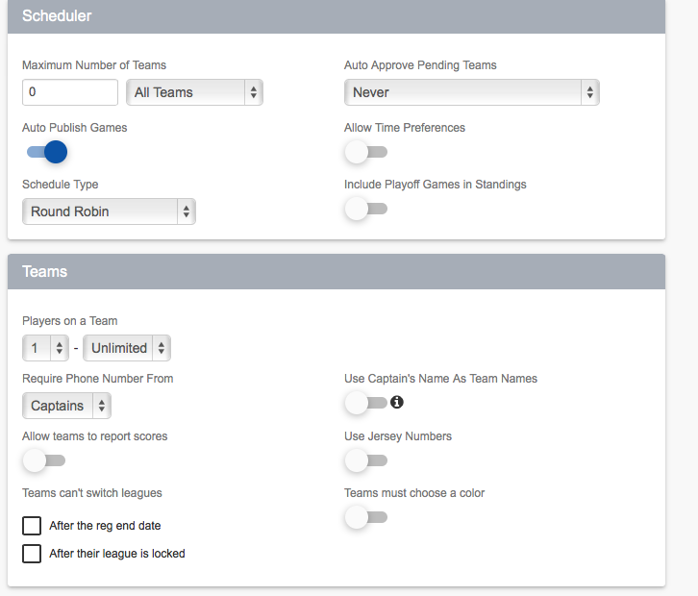
At the top you will see two things: “Fill in settings from” and “clone league” these are incredibly useful tools to use once you have already created one league – it imports the same information from one league into the next so you don’t have to fill all the dates, info, etc. over and over again.
  - (for more step-by-step instructions about things found on this page keep reading!)
    - GENERAL
      - League Name: i.e. Men’s Competitive, Coed B, etc.
      - League Type: choose from either CoRec, Mens, or Womens
      - (don’t worry about “advanced options”)
      - League ID: will auto-populate with League name unless you want to change it to something different.
      - Season: choose the season (summer, fall, winter, spring) and the year you want the league to take place
      - Active League: make sure this box is checked!
      - Teams are created at: you have two options here – “Division Level” (i.e. Men’s Monday nights, Men’s Wednesday Nights) or “League Level” (i.e. Mens)
    - PAYMENT
      - Depending on your school’s specifics click on the necessary boxes (ie. Team Payment and/or Individual Payment). IF you click on one of these boxes a space will open up so that you can specify the payment amount.
      - Coupon codes: if you want students to come to your office to pay before they create a team you can write that in the payment instructions area and then you can issue them a code to put in once they have given you the money. Participants will then use this coupon code when they are creating a team.
      - Accept payments online: if you wish to use this function please call the office so that we can explain in more detail how this process works.
    - TEAMS
      - Maximum Number of Players on a team: you can cap how many players are allowed on a team
      - Minimum Number of Players on a team: this sets up how many players need to be on a team before it is a valid team
      - Minimum Number of Females: this is used for teams in Coed leagues
      - Minimum Number of Males: this is also used for teams in Coed leagues
      - Require Phone Number From: you can decide if you want to collect phone numbers from “captains”, “everyone”, or “no one” when participants register
      - Use Captain’s Name as Team Name: this is mostly used for sports like tennis or badminton or if teams are not “trusted” enough to make their own team names during registration
      - Allow teams to report scores: if you enable this function it allows teams to input their own scores and the teams have 2 days to raise any dispute before the score is locked. Should a dispute arise, as an admin, you have say over the final score and can make any changes necessary.
      - Use Jersey Numbers: if teams always are using the same jersey numbers you can enable this area.
    - DATES AND REGISTRATION
      - Registration Start: input the date and time you want registration to open for the league
      - Registration End: input the date and time you want registration to close for the league (after this point no other teams will be allowed to be created)
      - Regular Season start: input the date for the start of the season
      - Regular Season end: input the date for the end of the season (these two areas become important in the scheduler area)
      - Allow players to join teams until: you can set a date and time, or a cut-off, that will not allow more players to sign-up after this date
      - Allow players to join teams anytime: determines whether or not participants can join teams whenever they want during the season
      - Players cannot join teams after registration end date: should you wish registration to close completely for participants at the date set above click this option.
8. Leave Team Anytime: Now you can set if players can leave teams until a specific date, or we have easy options to select registration end, season end, or anytime.
In addition to the above there is another great option to set that players can’t leave a team after they’ve played in X number of games. If you choose to use this option then it will restrict leaving based upon the games they’ve played OR the date selected, whichever comes first – for example if you set that players can leave teams until the end of the season or once they’ve played in 1 game, then they’ll be able to leave a team until the end of the season as long as they haven’t played in any games, but once they play in one game for that team they wouldn’t be able to leave the team

    - PLAYING SURFACES
      - If nothing shows up here you need to go into the facilities area and set-up your facilities and game surfaces (see “How to set-up your Facilities” instructions)
      - If surfaces show up click on the ones that will be used for this sport and league (ie. Practice Fields – Field 1, Field 2)
Click submit and your league has been created! Repeat this process until you have set-up all of your leagues (don’t forget to use that handy “Fill in Settings From:” tool!)
NOTE: if you have set-up your sport so that teams are made at the Division Level you will be asked to create these divisions that are housed in the league once you click submit. The process is much like setting up a league – let us know if we can help!

