Scoresheets
Here is a tutorial on how to make scoresheets for your programming
- In your sport settings you should have picked whether or not you want to use a “basic scoresheet” or a “custom scoresheet”:
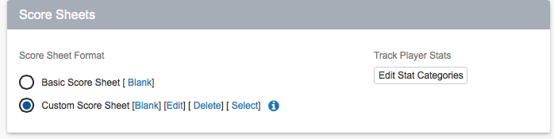

  - We suggest that you use the custom scoresheet (for your bigger sports) and choose from one of our templates we have already made. That way we get started with the basics and then you can add school specific details (i.e. logos, roster info, etc.).
    - If we don’t have a template made in the template area under “select” you can create your own as well – just click on “blank” underneath “custom scoresheet”
instead of “select” and you will be given a blank sheet to work with.

NOTE: If you want to just keep things simple use a basic scoresheet and most of what you need will already be done for you and you don’t have to create or alter anything
- To build a scoresheet:
To start working on your scoresheet you need to make sure you are inside your sport settings area!
  - Once you choose which template you want you will be brought into the scoresheet creation area (see picture below)
  - This area will show you your scoresheet along with widgets along the side (red arrow). These widgets can be dragged and dropped onto the scoresheet for customization [The one shown below is an example of a basketball scoresheet]
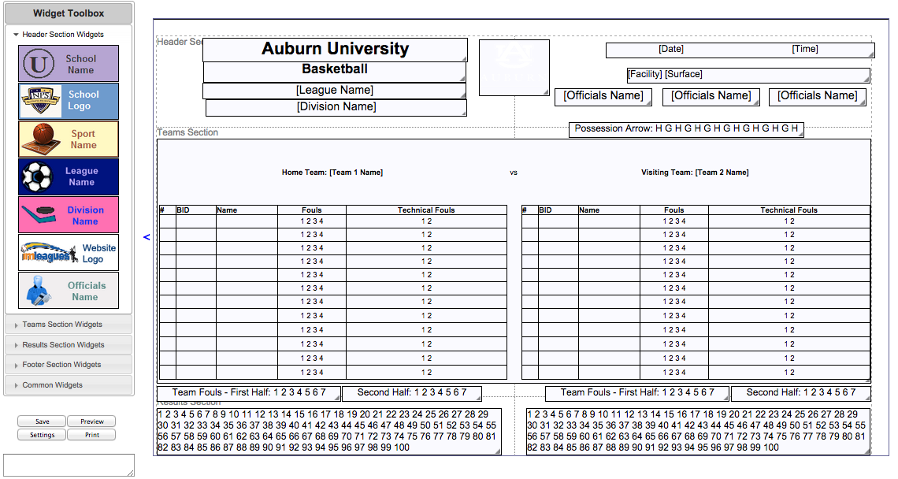

  - Anything you see along the top of your scoresheet in brackets, “[]”, will be automatically filled in when printing scoresheets for an actual game.
  - The roster area (large area with rows) will also fill in with whatever information you need (i.e. SID #, name, join date, phone number, etc.) automatically based on the information already in the program. As soon as you print out the scoresheets your rosters will be completely filled in.
    - To alter the information listed in this area double click on the roster box and an area will open up where you can change the columns and headings used. You can also enter customized columns (i.e. Jersey number, fouls, etc.)
  - Once you are happy with the way your scoresheet looks (and it can take some practice and fiddling around!) make sure you click “save”. Then you can click on the “x” in the upper left-hand corner.
    - Good things to make sure you have on your scoresheet:
      - Date/time of match
      - Location of match
      - Score tracking areas (foul tracking area – if necessary)
      - Sportsmanship entry area
      - Names of referees working the particular game
  - To print scoresheets for a game(s):
    - Go into your schools’ homepage and click on the link “Score Input/Printables” from the admin icon in the top white bar – you must have either admin rights or be allowed to print/input scores based on your referee capabilities as set-up by your administrator
    - In this area you will be given the option to search by a specific date, sport, etc, and once you select a date you should see the games scheduled for that day below.
    - Click on the little check box next to the game(s) you need a scoresheet for (see red arrow):
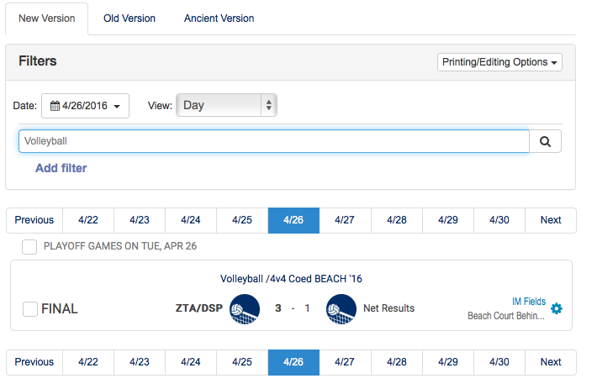
    - Once you select which scoresheets you want, go to the top of this page and you have a lot of options. To simply print just click on “Print Score Sheets” and it will export the filled in scoresheets for the game(s) you have selected to a PDF – you can directly print from the PDF after previewing the sheets.
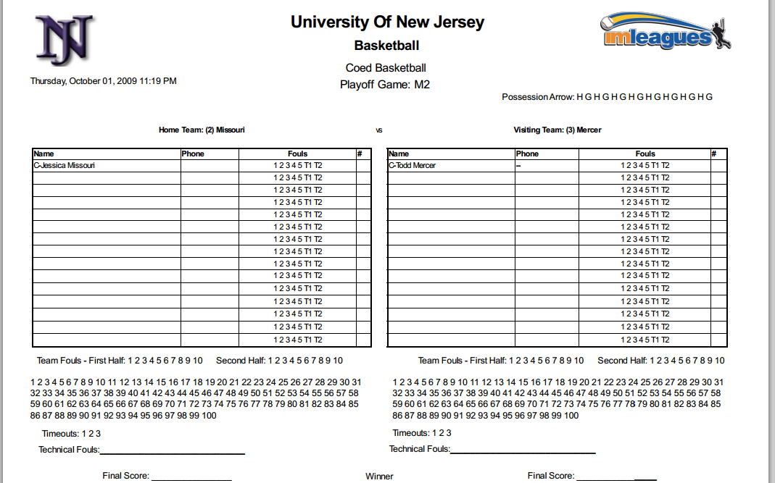
    - A filled in scoresheet looks something like this (obviously yours will have more participant information filled out for a real game):

Once again, scoresheet making can be a bit tricky at first so if you have any questions or can’t get it figured out please let us know and we can help get you fixed up!

