Participation Statistics
Is it time for that annual report again? Need to know your numbers? Well, here at IMLeagues we make it easy to keep track of everything!

- To get to the participation statistics area go to your homepage and then click on the “Participation Statistics” link under the “Admin” icon on the top white bar of your page.
- You will be brought to a page like this:

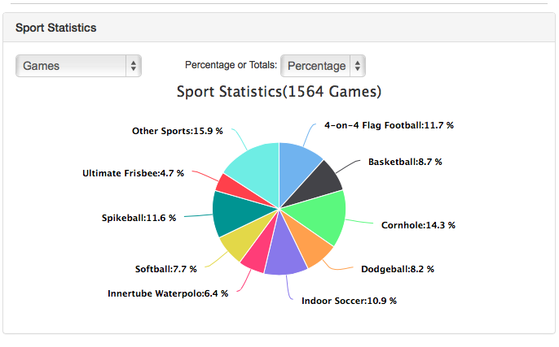

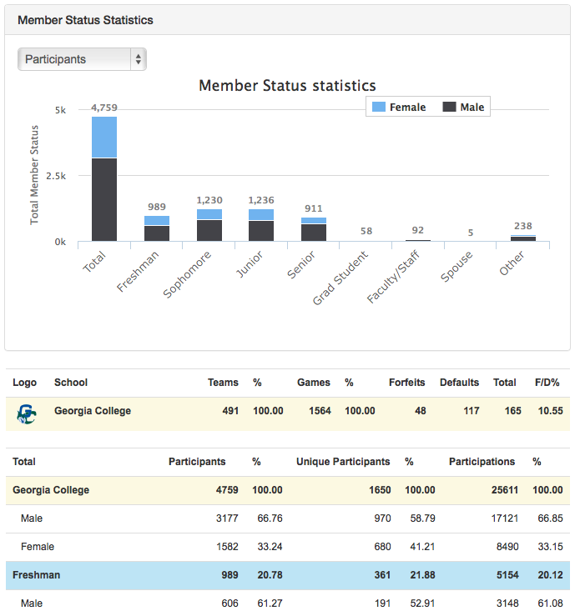

- On this page you will see a pie graph that breaks down all of your sports games statistics. You will also see a bar graph as an illustration of your member status statistics which shows your male/female breakdown by classification.
- Above the graphs you will notice dropdown menus where you can filter out your participation information. For example, you can determine the season and sport to get more specific information or you can click the button for “all seasons all sports” to get overall participation statistics for your program (since the time you started using IMLeagues).
- Below the graphs you will see an area that shows the demographic make-up of your sports and participants. From here you can see the total number of teams, your forfeit/default percentage, your male/female percentages, and your participation numbers based on classification (i.e. freshman, sophomore, junior, senior, etc.).
- You may have noticed columns titled “Participants”, “Unique Participants”, and “Participations”
  - Participants = how many people were listed on the roster for an event/sport (it will list people twice. For example, if Bob plays soccer and basketball he will be counted as 2)
  - Unique Participants = this is different than regular participants because, for example, if Bob plays both soccer and basketball, he will only be counted as one person in the unique participant category.
  - Participations = how many times people were checked in at a game. Shows how many times people showed up to play.

