Day-to-day “Jobs” for Student Employees
(including printing scoresheets and entering game scores)

To Print Scoresheets:

    - Login to your schools’ homepage, hover over the “Admin” tab in the top white bar and click on the link “Score Input/Printables” – you must have either admin rights or be allowed to print/input scores based on your referee capabilities as set-up by your administrator
    - In this area you will be shown a calendar (or you can search by a specific date, sport, etc) and once you select a date you should see the games scheduled for that day below.
    - Click on the little check box next to the game(s) you need a scoresheet for (see red arrow):

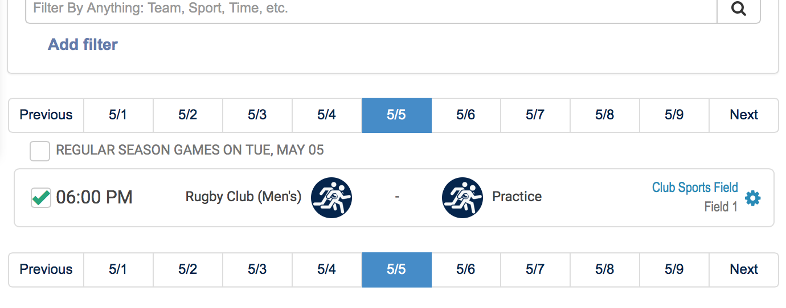

NOTE: to print all of the scoresheets for a particular date click on the little check box by “sport” (see green arrow) and this will check off all of the scoresheets below.
    - Once you select which scoresheets you want, go to the top of this page and you have a lot of options. To simply print just click on “Print Score Sheets” and it will export the filled in scoresheets for the game(s) you have selected to a PDF – you can directly print from the PDF after previewing the sheets.
Notice that you can also print off Team Rosters and Game Schedules from this area as well. By utilizing the filters to the left of the calendar, you can decide exactly what score sheets/rosters/schedules you’d like to pull up.
You can also “select” the words below the calendar to sort through by day, week, month, and entire season. All of these are printable as well, just by clicking the appropriate checkboxes to the left of the matchup of the game! (Or you can “select all” by clicking on the “sport” button above the matchups
How to Enter Game Scores
- If you have been given access to edit scores by your administrator follow these directions to update scores:
  - Login to your school’s IMLeagues homepage
  - Click on “score input/printables” along the lefthand side of the page
  - Go to the date on the calendar you wish to enter scores for and then find the game you want to enter scores for.
  - Click in the center of the game that you wish to enter scores for and this will open up the scoresheet input area that looks like this:

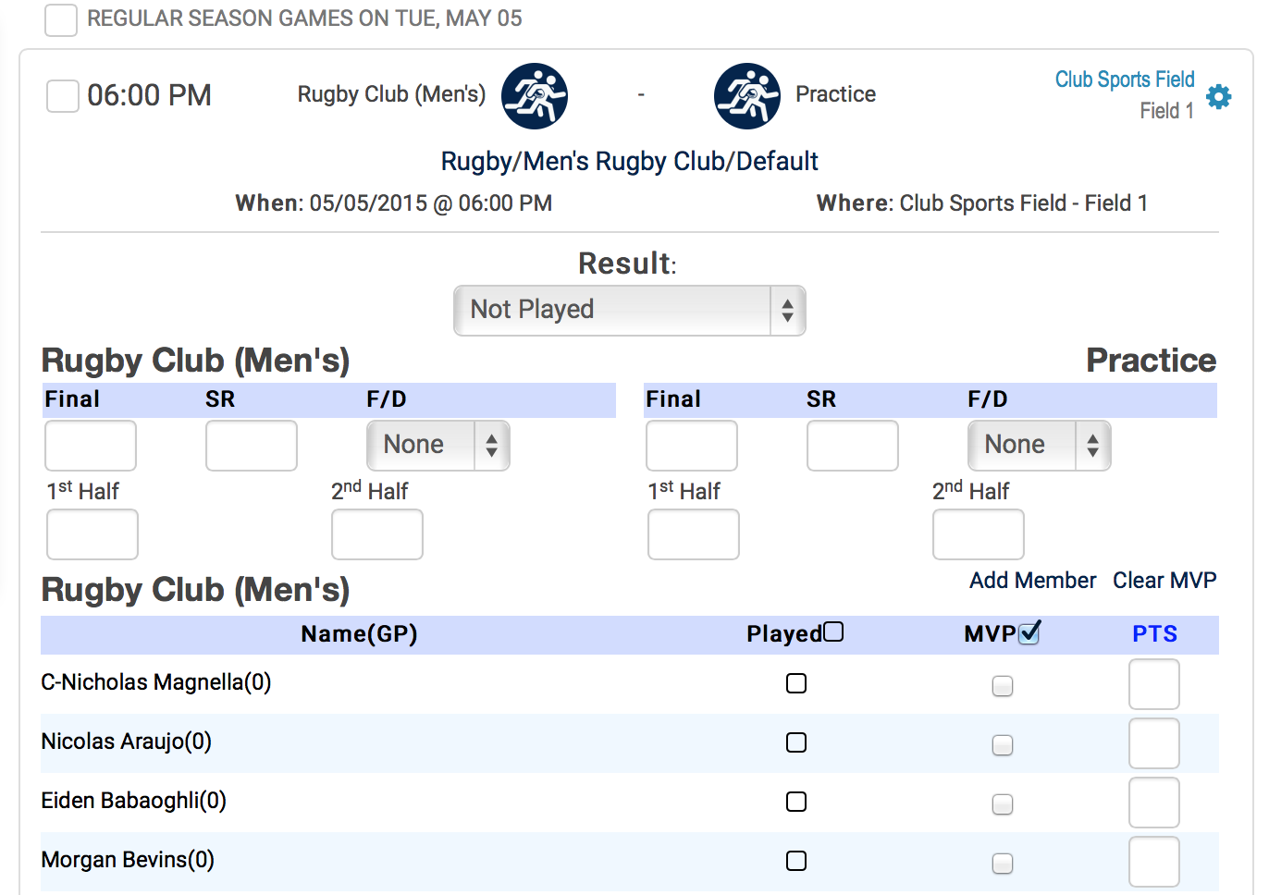

- In this area you can enter the Final Score (notice how the winning team turns green and the losing team turns red!), Half-time/Set/Quarter scores, and the Sportsmanship rating (SR) in their corresponding boxes.
- Below these input areas you will see the teams’ rosters. Next to each person you will see an empty box. If the person showed up to play in the game click on the box and the box will change from empty to checked– this officially checks them into the game and counts towards participation
- You can also check the MVP box next to the corresponding person (some school’s allow participants to do this on their own)
- IF a player came to a game but is not yet on the roster you can add them to the roster for future games by clicking on the “Add Member” link below the corresponding team. This will open up another page where you can search for the person in the IMLeagues system.
  - If the person shows up as already in the system you can simply click “add to team”
  - If the person is not yet registered in IMLeagues you can create their account by entering their information in the boxes that should pop-up when nobody in the system is found with the name you have entered.
    - HINT: make sure you are entering the person’s correct email address, it helps to check in your school’s own directory.

