Setting up your Referees

- There are a few things under your “Intramural Settings” that need to be determined as far as your referees go. Go into your Intramural Settings” by hovering over your “Admin” tab and click on “Intramural Settings.” Scroll down until you see a box that looks like this:
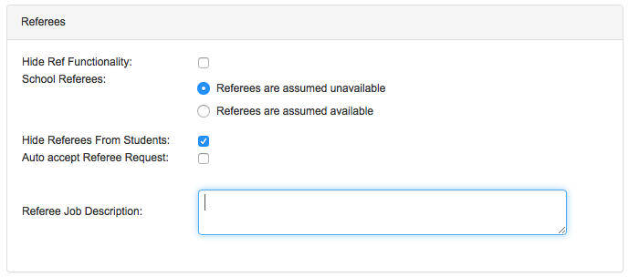

- Hide Ref Functionality: if you do not need referees for this sport it will hid the referee assignment option in the game schedule area.
- School Referees: the two options here are “Referees are assumed unavailable” and “Referees are assumed available”. If you pick the unavailable option referees have to put in their schedule based on when they can work. If you pick the available option referees have to put in their schedule based on when they cannot work.
- Hide Referees from Students: if you do not wish your participants to see who is working their games you should click this option (helps to keep pre-game conflicts from occurring)
- Auto Accept Referee Request: (not usually recommended to enable) Allows referees to automatically sign up for when they want to work
- Referee Job Description: input job description if you wish people to be able to see what the referees do in case they are interested in the job and/or any information about where to apply, etc.

- To assign someone as a Referee:
  - First, the person must already have created an account in IMLeagues
  - Once they have created an account:
    - Go to the “Referees” link on the left hand side of your page under your Admin Links
    - You will be taken to a new page that has a button that says “Add New Official” on the top right hand side of the screen.
    - From this page you can search the person’s name you want to assign as a referee and then next to their name you should see a link that says “Add to Officials” click this and you will be brought to a referee assignment page that looks like this:
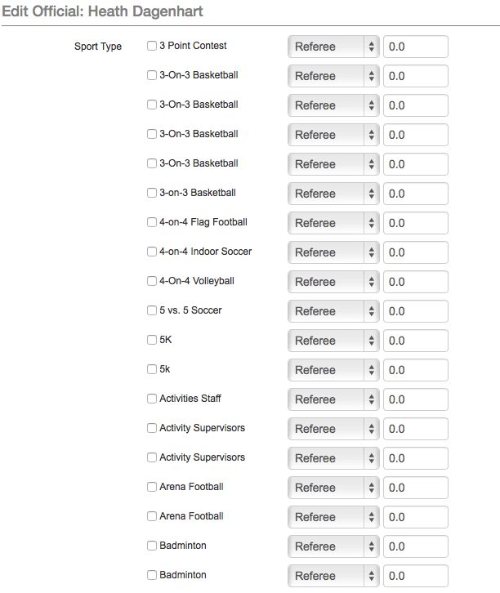

    - On this page you can indicate which sports you want this particular referee to be able to work (just check the necessary boxes). In the dropdown menu you can set the person to be a referee, scorekeeper, supervisor, umpire 1, or umpire 2. In the numbered box you can also add a rating to indicate which referees are your strongest and which might be a little weaker – depending on the sport.
    - Allow editing scores: click this box if you want to allow the referee to input scores.

  - Once you click submit that person will now be set-up as a referee and will show up in the referee area:
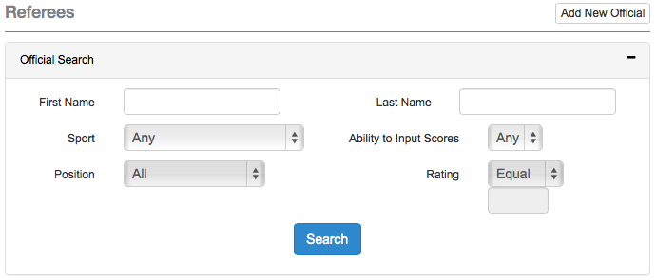
In this area you can see which sports each referee has been assigned to work with, whether or not they are allowed to input scores. Using the blue “Actions” button you can view their work schedule, edit their referee profile, and remove them from being a referee.

- If a student is set-up as a referee they will now have to enter their availability
  - The need to login to their account and look on their calendar. There should now be a button on their calendar that says “Add Ref Availability”:
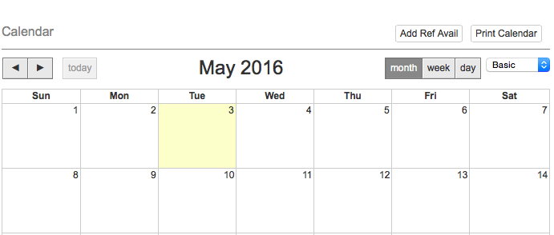

From here each referee can put in the times they can work by clicking on “Add Time”. They have the option of putting in repeating days/times or just doing their calendar by specific days/times.

To schedule referees, you will need to have a schedule in place, and then you can go to either the game schedule page (click anywhere on the game matchup to assign refs) or the scheduler page (click on the “ref” column and manually assign your officials to each game).

