Captain Quizzes: Creation and Assignment

- There are two steps to setting up captain’s quiz: You must first create the quiz at the SPORT LEVEL and then assign them each individually at the LEAGUE LEVEL.
- To create a quiz, click on the sport page or the image associated with the sport:
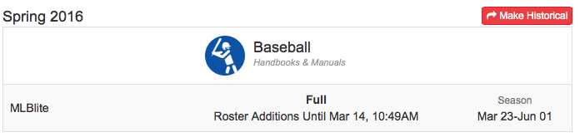

- You will then look in the top white bar above and see the Quiz icon to click on:
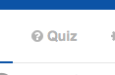
- You will be taken to the quiz page where you can the select “Create New Quiz” or “Import Quiz From Another Sport”:
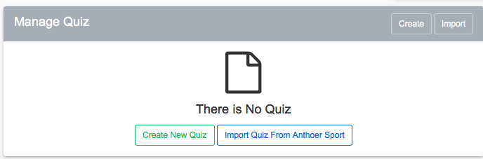

- Set the parameters for the quiz on the next page. You can allow them to review the correct answers upon completion of the quiz if they don’t pass the first time. You can also require the students watch a video before they take the quiz by copying and pasting an embed code from YouTube:
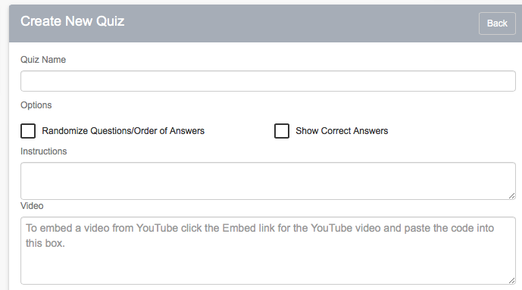
- The quiz questions can be either multiple choice or True/False and you will create the question, type in the possible answers, and choose which response is correct:
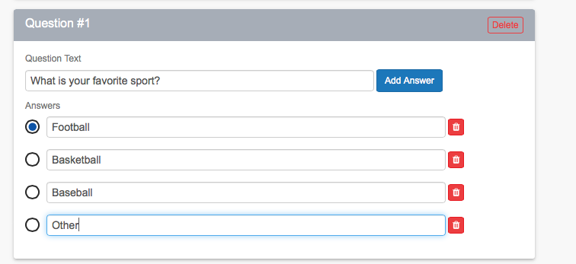

Once you’ve created the quiz, you are not finished!!! You still have to assign the quiz to each league within the sport you’ve setup. To do this, click on the individual league and go into the league settings.

- You will scroll down and see the “Quizzes” area in the league settings, and you will want to click where it says “collapsed” to expand the options:
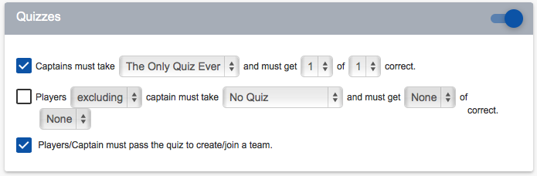
- You can specify which quiz you want them to take and how many they need to get correct to pass.
- You can also have the “members” in addition to the captain take the quiz and specify how many they need to get correct to be a member of the team
- You’ll notice the final option is that you can choose to make passing the quiz a BARRIER to creating/joining the team. We recommend this because you’ll automatically require anyone that has created a team to pass the quiz. If you choose to not go this route, a captain that has not passed the quiz will have a line through their name that says “Quiz” next to it on any roster page, scoresheet, or printout.

