Campus Cup
*the easiest way to get a Campus Cup started is to set it up at the beginning of a year
To start:
- To enable the Campus Cup function, go into your school settings and check the box next to “Campus Cup”. This will put a new tab on your school’s homepage which gives you access to the Campus Cup area:

- As an Admin, you have the choice to either “Auto Approve Group/Greek” in your school settings area or you can decide to create the group on your own (it just depends how much control you want over your program. HINT: if you leave it up to students, some of them are too lazy to create a group and then your Campus Cup may not turn out how you want it to).
  - For those who want to use the “Auto Approve Group/Greek” function this will allow your students to make their own group and you will get a notification once it is made to ensure that it is a legitimate group.
  - For those who want to do it the other way:
    - Once you have enabled the Campus Cup, click on the tab from your homepage and you will be brought into the campus cup area. On the left you should see a “Cup Settings” link.
    - In your cup settings area you can add a new cup by putting in the cup name (i.e. Frat Cup, Sorority Cup, Sportsmanship Cup, etc.) and setting the year. Then click “Add Cup”
  - Once your cup(s) have been created just click back on the Campus Cup tab and you will be brought back into the page. From here you can add a cup description and announcements. Also from here you can create your Groups that you want participating in the cup.
    - To do this click on the Cup you want to add groups too and then click on the “Create Group/Greek” button. (If you have already made a group(s) it is going to give you a red lettered warning that you are already a member of a different group – just ignore this for now and click on the “continue” button)
    - On the next page you can add the Group name, a picture, and also designate which Cup this group will be participating in. To finish click “Create Group”

When the group has been created you will be brought into the Group’s page (it looks a lot like a regular team’s page)
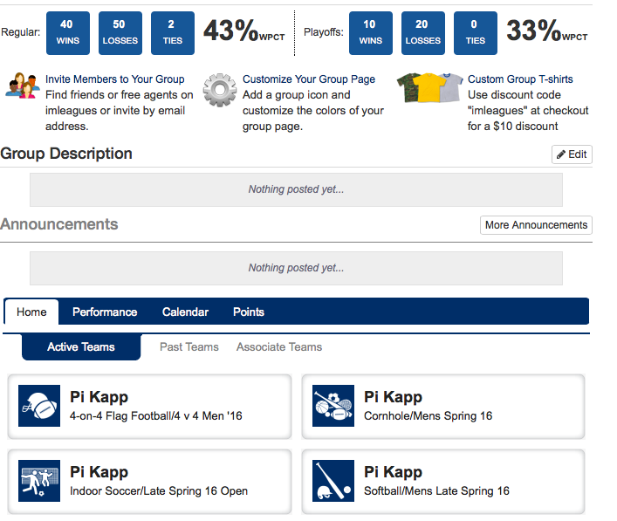

Now, since you created the group (but as an Admin aren’t necessarily part of the group) you are going to want to transfer the “ownership” of the group to another person who is affiliated with the group.
- Once you affiliate this person they will be able to be the “chair” which will give them the abilities to add members to the group, customize the page, and associate teams with the group)
- To do this:
  - Inside the group’s page click on “Add Member” under your admin links along the left-hand side of your page.
  - From here you can search the person’s name and click “add” if they already have an IMLeagues account (if they don’t already have an account you can create an account for them and add them that way – just like adding a member to a team)
  - Once the person is added, go back to the Group’s page and click on the “Members” link along the left-hand side of your page. By opening this area up you will see everyone who is a part of this group. To remove yourself from the group and make someone else the Head (a.k.a. Chair) just click the red “x” by your name and it will prompt you to select the new chair for the group (you can notify the person through text message that they have been designated as head by clicking the box below).
  - The Head, or Chair, can now affiliate teams with this group by going towards the bottom of the page and clicking on the “Associate Teams” tab. This will bring up the teams the Head is already a part of and they can pull them under the umbrella of the group by clicking “Associate”. They can also search for other people’s teams that would fall under this group and add them as well.
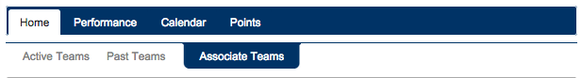
NOTE: only active teams in active leagues can be affiliated with a group

For Admins: filling in points for the Cup.
- Once a team has participated in an event you need to add the points that team has earned by participating (this is completely based off of your own school’s point system)
- To do this: click on the Group (from the Campus Cup homepage) and then click on the necessary team. Then go down towards the bottom of the page and click on the “Points” tab:
From here click on the “Add Points” button and then you can input points in the various columns. You MUST add the points to the ones already in the columns, do not erase! (ex. if you want to add 10 points in a column that already has 50 points you should enter 60 in the given box). To finish click “Submit Scoring”.
NOTE: you can “reuse” groups from year to year. Just go into the Group settings and change the “Cups to Compete In” – you will be prompted with a menu to select which cup to reassign the team to.
