How to Use the Scheduler/Make Game Schedule
Ok, so now it is time to make a game schedule – it may look complicated at first but you can do it!
AFTER your registration period has closed is when you want to go ahead and make your game schedule for whatever sport you are running. To do this follow the directions below
- Login to your school and go to the homepage
- Click on the sport you wish you schedule
- Click on the league within that sport you want to schedule (if your school runs divisions go into the division you want to schedule)
- Once in the league (or division) you should see all of the registered teams – it will look like the example below:
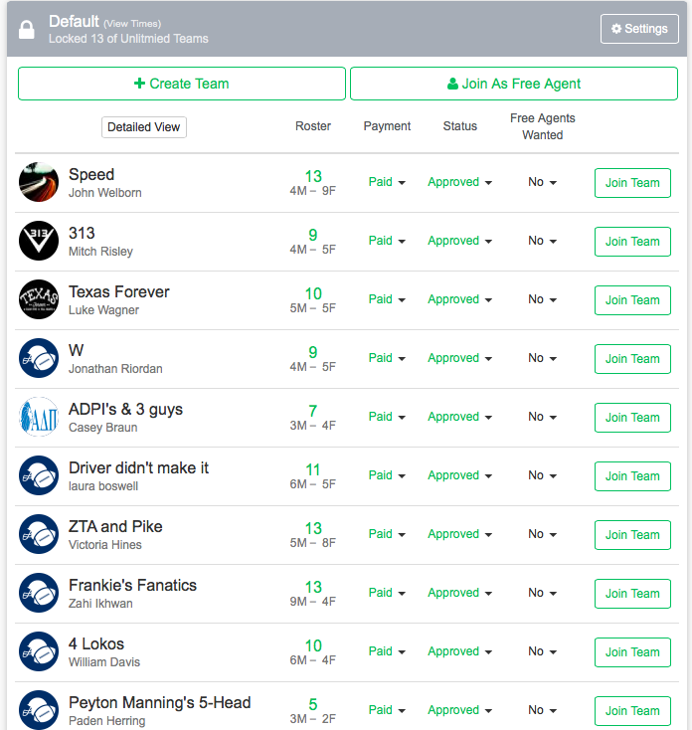

This area lists the team names, the captains, how many members are on the team, as well as if the team has been approved.
- The approved column is important. Some schools set their leagues up so that once a certain minimum player requirement is met they are automatically approved. Other schools set it up so that an admin has to manually approve each team. If you are the latter, make sure you approve all of the teams you wish to schedule (otherwise they will not be scheduled). TO APPROVE TEAMS: Click the drop down boxes in the status column and change the team from unapproved to approve.
- If a team payment is required there will be a payment column that will say whether the team has paid or not. You can mark whether they have paid or not by clicking on the status like you would for approving a team.
- The “move” feature allows you to move a team from one league to another or from one division to another. Simply pick that team you want moved in the dropdown menus and where you want them to go (Again found in detailed view.).
- The detailed view of the teams will look like this:
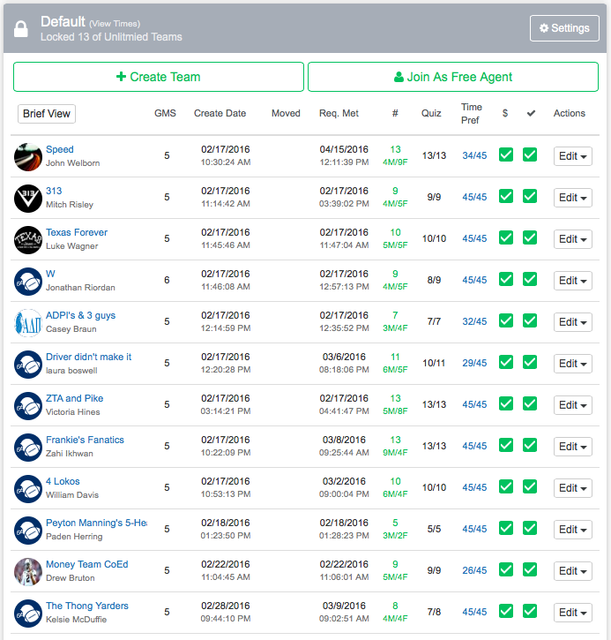
- After you have approved all of your teams go back to the top white bar (under Admin Links) and click on the “scheduler” link:
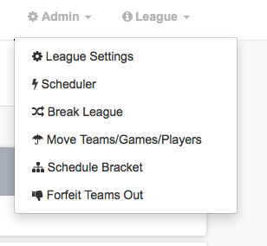

- You will be brought into the scheduler function page that looks like this:
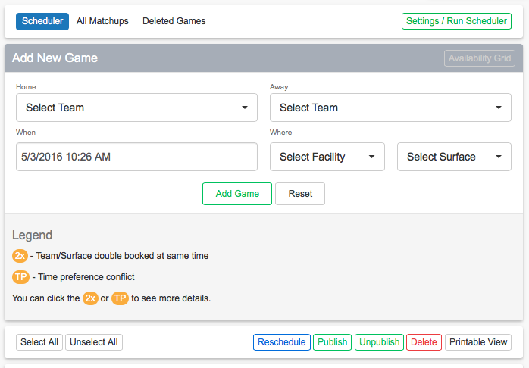

From this front page you can schedule a specific game or, if you want to schedule a whole season, click on the “Settings/Run Scheduler” link (see red arrow above)
- Below is an example of a Scheduler Settings page. (Explanations of each of the following settings and how to run the program are below the picture)
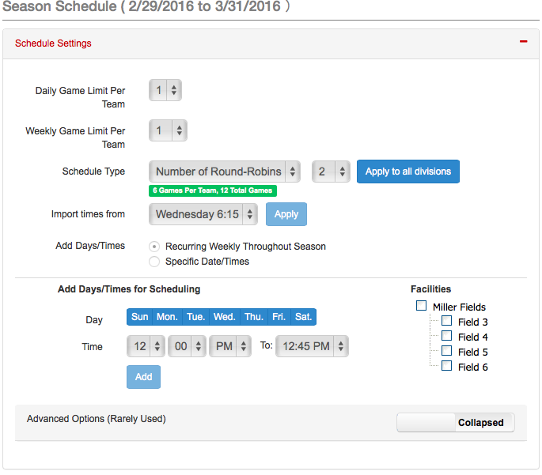

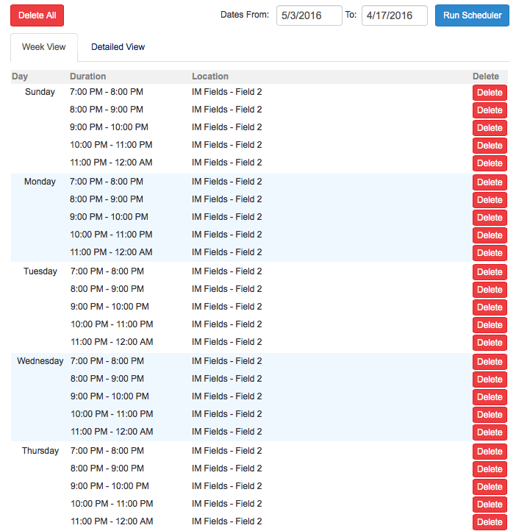
At the top of the page you will see the dates of your regular season that you had set-up when making your sport.
- Number of Games Each Team Plays Per Day: puts a cap on how many games a team plays on a given day
- Number of Games Each Team Plays Per Week: puts a cap on how many games a team plays in a given week
- Day of the Week to Start Scheduling: pick the day of the week you want the scheduler to start from (default setting is Sunday)
- Force time preferences to satisfy games per week: if you have enabled time preferences for your participants you want to make sure this button is clicked. This will allow the scheduler to make match ups for teams even though they may have marked themselves as unavailable – it will try to satisfy time preferences first though.
- Generate randomized game schedule: if you click this box, each time you run the scheduler you will get different game match-ups.
- Schedule type: This can either be set up as “number of round robins” or “games per team” based on your preferences. (Don’t forget to select the proper number to the right!)
- Import times from another league/division: if you have already set-up your scheduler for another league or division you can import the same timeslots you used – time saver!
- Now you have two options for adding time slots:
  - Use standard scheduler: below you can put in repeating dates and times in the area below called “Auto Scheduler Days” and the program will automatically populate all of those days and times during your regular season.
  - Use specific date/time scheduler (IPS): if you want to go day-by-day in scheduling (for example, when you share facilities with athletics) you can use this option. Once you click the button an area will open up where you can put in your days and times one by one.
- Once you have entered all of your dates/times click on the “Detailed View” tab and it will show you all of the game time slots that you have listed as available for the scheduler to use. If you need to delete a specific date or time simply click on the red X to the left and no games will be scheduled for that time.
- Finally, click on “run scheduler” (see red arrow in above picture)
After you run the scheduler you will see that the program has made all of your game match-ups and it will look something like this:
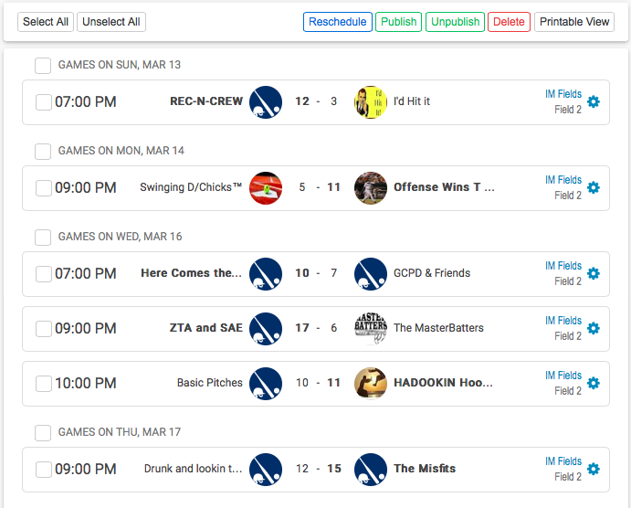
This is a listing of all of the games in the regular season. It shows the home and away teams, the date and time of the game, the facility and surface the game will be played at, the status (i.e. to be played, awaiting scores, etc.).
- Under the” Refs” column you can assign referees to the games by clicking on the “none” and it will bring up everyone who is listed as a referee in your school (you can sort by position and sport) and then you can assign them to the game by clicking on the “add” button.

NOTE: at the top of the page you will see buttons where you can publish the games (meaning they will show up on participant’s calendar), unpublish the games (if you want to keep the games hidden for a time – for example, you don’t want people to know their schedule until they come to the captain’s meeting), and you can also click on “printable view” to print out the schedule if you want to post a paper version.

