How to Steps: When the Scheduler Doesn’t Do What You Want

When the Scheduler doesn’t schedule enough games:
From the league page (division page if you have divisions), click on the “Scheduler” button (see below) and scroll down to the schedule:
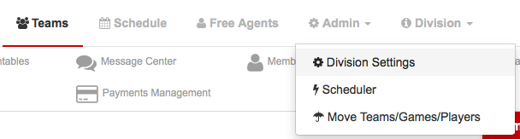

Scheduler Page:
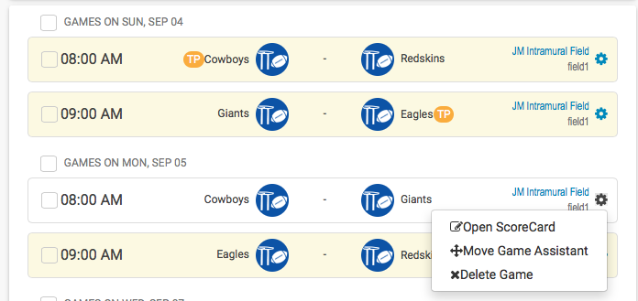

Click on the little gear to open up the Move Game Assistant function to look at all games and the schedule.

You will then see this screen:
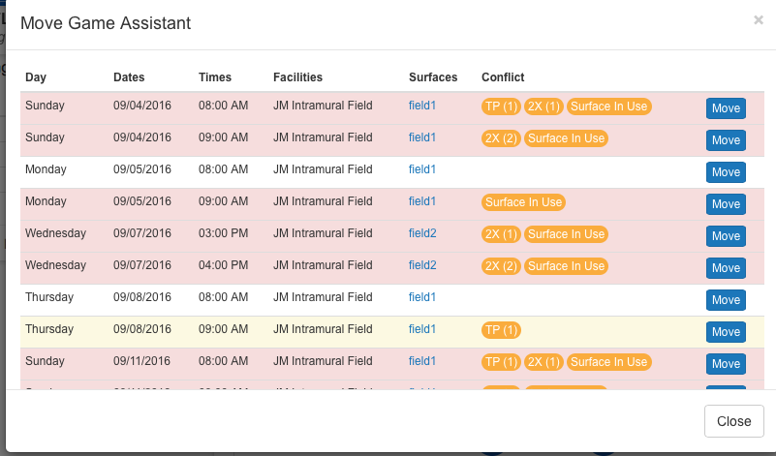
The games will be marked in red if there is a conflict and then the conflict will be listed out to the right saying that all of your FACILITIES/SURFACES ARE BOOKED! (Consult the legend in the scheduler for what each abbreviation means)

If you are seeing times available, but the scheduler hasn’t scheduled enough games, this means you need to RE-ADJUST YOUR SCHEDULE SETTINGS.

To do this, follow this check list:

Verify that all of the teams you want scheduled are approved are highlighted in green next to their team:
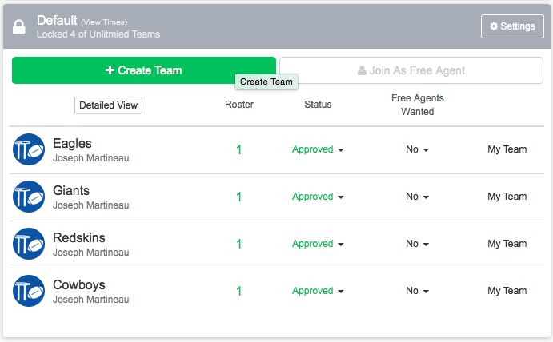
If the team isn’t approved it will say it in black lettering. To approve them, simply click the status and the drop down box will let you change them to approved and will show it in green.

2. From the league page hover over the “Admin” link and click “Scheduler”: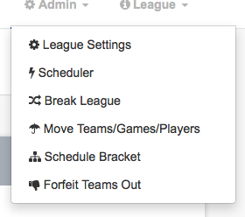

3. Click on the green “Settings/Run Scheduler” Button:
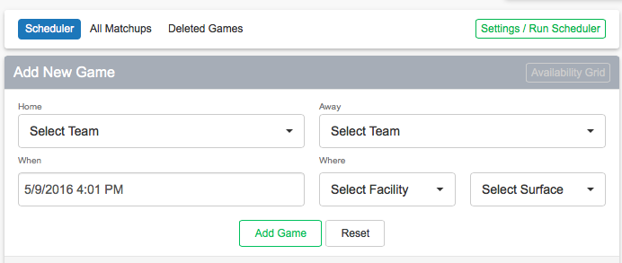

4. Scroll down to the “Add Days/Times” and make sure that you have added your time slots, and that they are correct.:
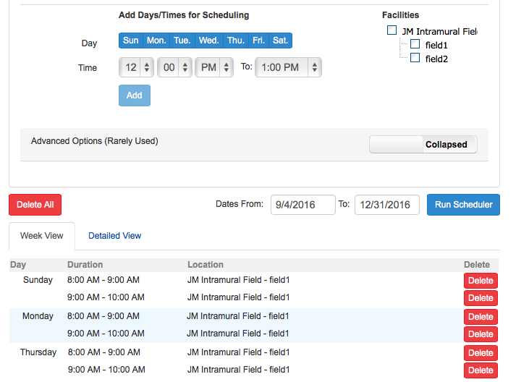
Click on the “Detailed View” to delete out any time slots you will not be scheduling games.

4. Scroll back up to the “Schedule Settings” and verify that the settings are correct:
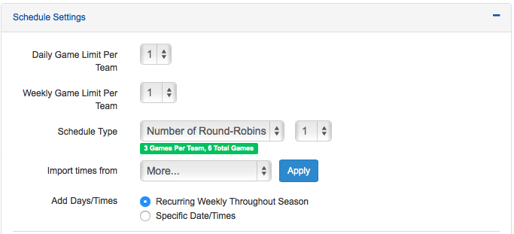
NOTE: IF YOU ARE NOT GETTING ENOUGH GAMES, YOU NEED TO ADJUST THESE SETTINGS! “Games Per Day” is the number of games you want EACH TEAM to play per day. “Games Per Week” is the number of games you want EACH TEAM to play per week.

If you notice the scheduler isn’t scheduling enough games or filling up all your time slots, try increasing the “Games Per Week” to 2, or an even higher number. This does not mean EVERY TEAM will play twice a week, but it will fill up some of those empty time slots.

This could take some trial and error….Re-run the schedule until you maximize your usage of time slots!

You can also verify how many games each team has been scheduled for in the regular season by looking at the Scheduler Summary after you run the scheduler. You will click on the “Settings/Run Scheduler” box first and then up top be able to see the summary.

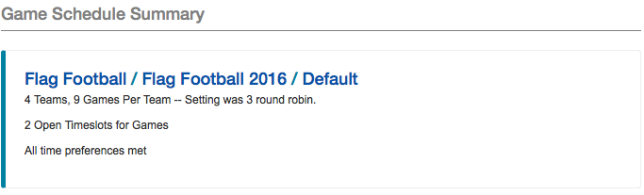

5. If the scheduler still isn’t doing what you’d like, there may be a couple of conflicts with either FACILITIES or TIME PREFERENCES.

Click on the “All Matchups” button and this will show you all of your games that were scheduled, and games that were supposed to be scheduled based on the parameters you set:

When viewing the “All Matchups” page, you will notice which games were scheduled and which ones were not. When a game was not scheduled, the DATE area will be blank (see blue arrow below!). If the game was scheduled, there will be a date/time next to the game.

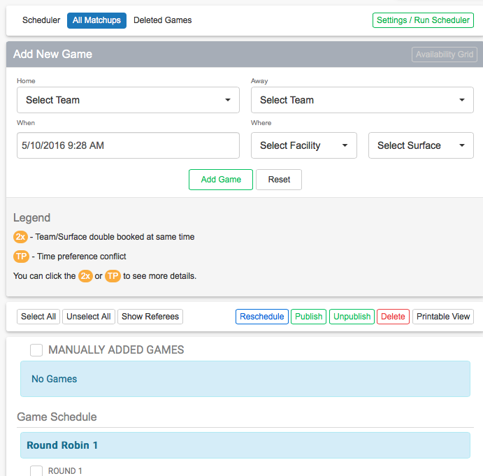

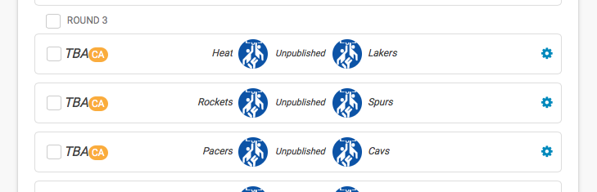
As mentioned earlier, games that were not scheduled most likely have a conflict with either FACILITIES or TIME PREFERENCES:

Conflicts with FACILITIES: You may already have games scheduled at that facility/surface with another league. This can sometimes happen if you are importing times from different divisions and forget that you already have scheduled games. To verify this, click back onto the school home page, hover over “Schedules”, and click “Facilities”:
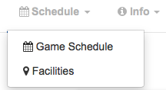
To view each facility’s schedule, click on the facility and scroll down:
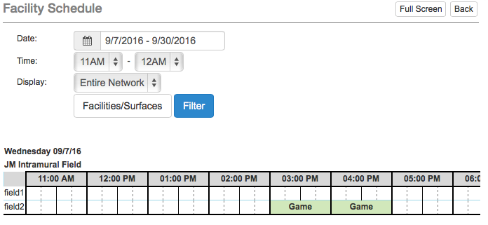

Cross-reference your league schedule with the ALL MATCHUPS page and see if there is a reason the scheduler did not schedule games. (ie. You already have a game at that time!)

Conflicts with TIME PREFERENCES:

Sometimes, the scheduler may not be scheduling enough games because you’ve allowed teams to mark off too many times as “Unavailable”. To verify this, click into the “league settings” (“division settings” if you use divisions) and scroll down to the “time preferences” area:

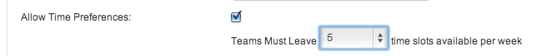

As an example, let’s say you have 10 time slots per week in a given league. (Maybe you play from 5PM-10PM on Tuesdays and Thursdays for a total of 10 time slots per week). The general rule of thumb is for captain’s to leave at least half of those time slots available per week. So, if you have 10 total per week, you’d want them to leave at least 5 available. (Note: We suggest that you err on the side of caution with this!...Make them leave as many available as you see fit! Which could be more than half!)

You can then verify ALL the team’s time preferences by clicking on the “Scheduler” page and then the “Availability Grid” shown here:
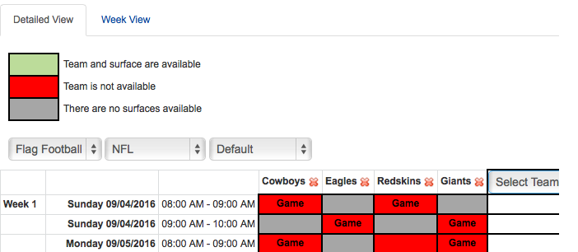

One final area to check is the length of your regular season. Sometimes, you’ll want each team to play a certain number of games in the regular season, but based on the time slots you’ve put in and the facility availability you have, it’s simply not possible. Make sure you’ve allotted enough time in the regular season by double-checking the league settings (regular season start and end date). Also, click on the “Settings/Run Scheduler” page for the league and make sure the regular season dates matchup together:
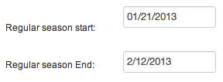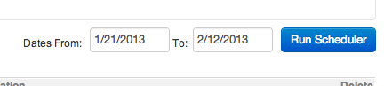

If you’ve tried everything mentioned above and the scheduler is still not working just the way you like, hop onto our LIVE CHAT and we will be more than happy to assist you!

