How to Set-up a Playoff Bracket
- Now that your regular season has ended it is time to make the playoff bracket. To get started go into your sport league division (if necessary), hover over the “Admin” icon and click “Schedule Bracket”:
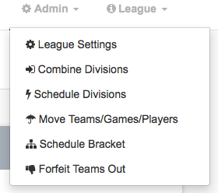

- To add a new bracket click on the “Add New Bracket” button at the top of the page. (If you want, you can also set-up time preferences for playoffs by clicking on the “set-up time preferences” button at the top of this page as well”
- You will now be brought into the playoff bracket generator:
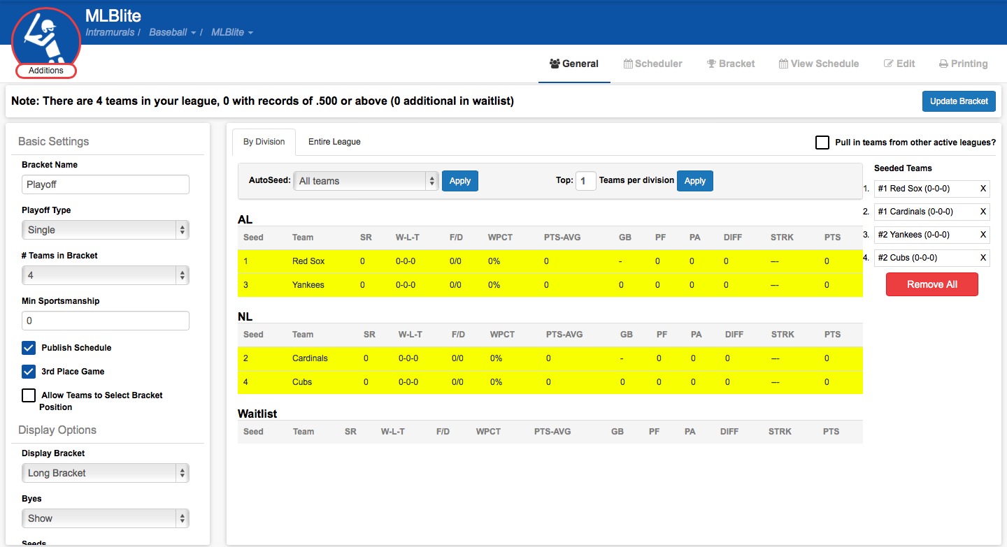

From here you can set-up your playoff preferences:

Bracket Name: input whatever name you wish to assign the bracket
Playoff Type: you can make it either “single” or “double” elimination
Byes: can either show or hide the byes on the bracket
Seeds: can either show or hide the seeds on the bracket
Min. Sportsmanship: enter in a minimum sportsmanship rating in this box. Any teams below this rating will be crossed out and not added to the playoffs.
# of Teams in Bracket: determine how many teams you want participating in your playoffs
Display Bracket: choose from either “long bracket” – shows the bracket top to bottom/left to right or “butterfly bracket” – more like March Madness style with the final teams meeting in the middle
Allow teams to select bracket position: if you want your teams to select their own space in the bracket you can do so by clicking this button. If you choose to do this a box will open up that will list the date and time the team will be able to select their bracket position.
Pull teams in from other active leagues?: this option allows you to add teams to your playoffs even if they are in another league or division.

(In the Seed Options area):
- Click on the tabs depending on if you want to schedule the playoffs “By Division” or “Entire League”
- Now you will see all of the teams in this particular league/division as well as their sportsmanship rating )SR), their record, and all other stats.
- In the area above, in the “Auto Seed” dropdown menu, you can either choose “All Teams”, “Randomly”, “Seed teams .500 and above”, or “Seed teams below .500” depending on your preferences. Click “Apply” and the seeds will be assigned.
- Once the teams are seeded they will show up – in order – on the right side of your screen under “Seeded Teams”. If you need to make any changes here you can manually adjust teams by clicking and dragging them around
- After you have all of this set up, click on the “Generate Bracket” button, and your bracket will be made:
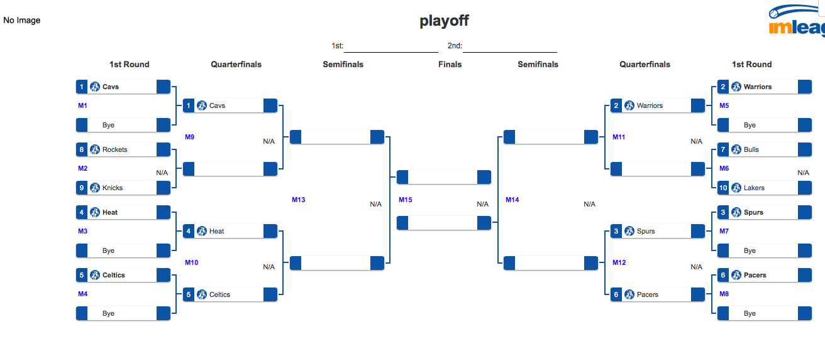
Now, along the top you have probably noticed some tabs:
General: will bring you back to the bracket settings page (i.e. seedings, preferences, etc.)
Scheduler: this area can be used much like the regular scheduler function and will assign time slots to games automatically once you set-up the game time slots

Note: If your bracket is small enough where it would be easier to just manually schedule each game, we recommend it! Sometimes it’s just quicker!

View Schedule: this will take the bracket and put it into more of a traditional schedule view (like your regular game schedule looks like)
Edit: you can go into your bracket and manually adjust match ups, game times, etc.
Printing: here you can set-up your printing parameters and either export to a PDF or print directly from this page.

Important: Make sure your bracket has been published – only then will games show up on participants’ calendars.

