How To Setup Ladder Scheduling on IMLeagues

Ladder Scheduling is used for individual sports such as tennis, racquetball, etc. It is meant for participants to challenge each other and setup matches on their own time, in which they can move up and down the ladder.

- Ladder scheduling is setup by going into the league settings and scrolling all the way to the bottom to “Schedule Type”:
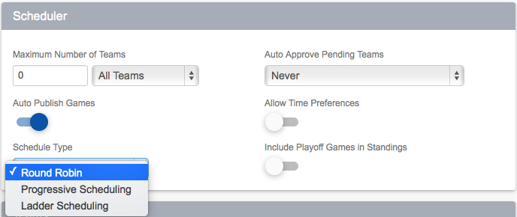
- The options are pretty self-explanatory. You’ll also want to make sure that “Allow teams to report scores” is turned on:

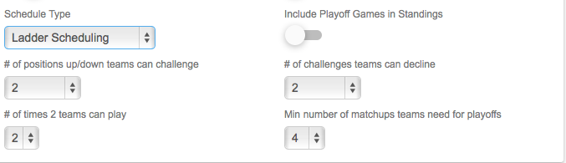

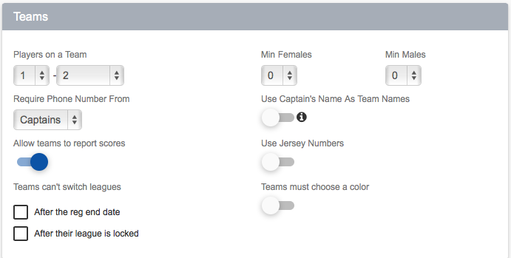

- As an Admin, you can arrange the ladder any way you’d like before play begins by locking the league and clicking the “edit” button:
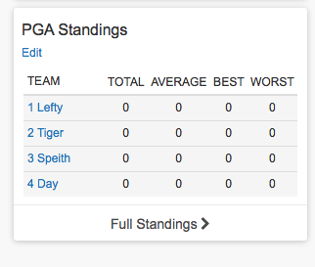
- You can drag and drop teams however you’d like:
