How To Challenge Opponents on IMLeagues

- To challenge a participant to a match, click onto your team page or the league page of the sport so that you see the list of teams…you will see a challenge button next to the teams for which you are able to challenge:
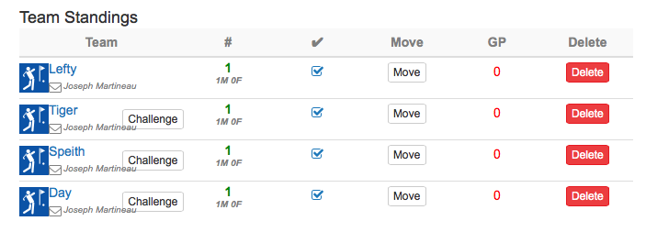
- From that page, you can enter in availability and contact information:
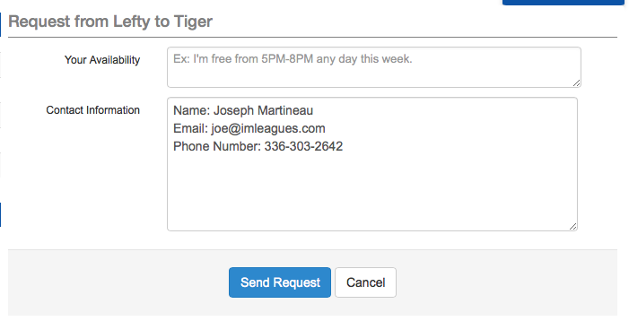

- Whenever you send or receive a challenge request, you or your opponent will see a red notification in the globe at the top of the screen:

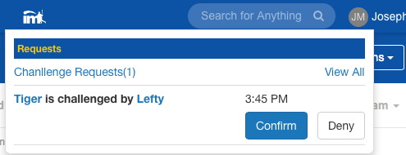
You will receive an email notification when you receive a challenge request, and you can also see it on your user home page:
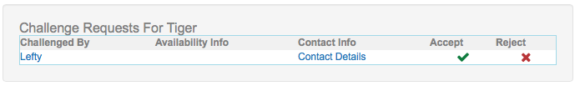

To Submit a Score for a Challenged Match:

- Click on your user home page (the page you see when you first log in) and scroll down to the “My Teams” area, click onto your team page, scroll down and you’ll see a blue “report score” button next to your most recent match.

NOTE: Once a score has been submitted, the other player has 12 hours to confirm the score (they confirm by logging into their account and clicking the “confirm/dispute score” alert on their user home page), or it will automatically be posted. Also, you can only challenge one person at a time. If you have a pending challenge and want to challenge someone else, your pending challenge will be canceled. Once a score has been submitted, you are then free to challenge again.

