Setting Up Heat Style Sports on IMLeagues

When setting up a sport on IMLeagues, you have the option to set it up as a “Regular” sport or a “Heat Scheduling” style sport. Please Note: A heat scheduling style sport is only used when an individual goes against the field, such as a race or swim meet. If you are setting up a weekend tournament (a la bracket style), you’ll still set up just a “regular” sport.
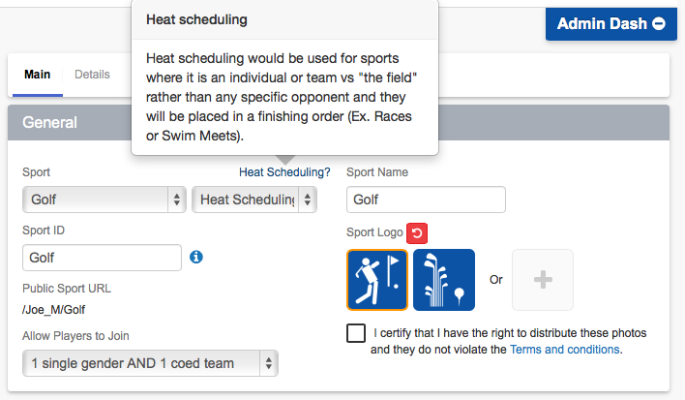

Another Note: You will still setup a “sport” and then a “league”, but you have to use LEAGUE LEVEL joining. As of right now, you cannot setup a heat style sport at the division level.

- You’ll notice when you setup the “sport” you have some specific “heat style” options in the sport settings: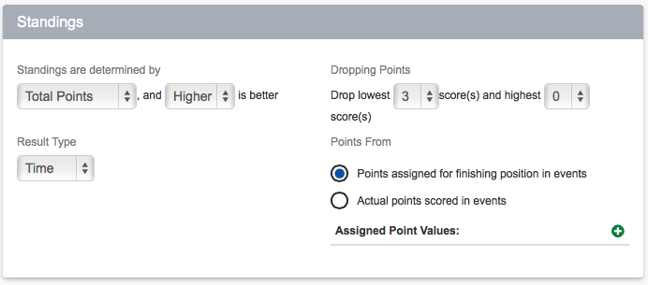
- You will determine the standings using these options. As an example, a golf tournament would be a possibility where “lower” is better. You can also enter in a time, a score, or a position.
- You can assign the results as either time/score/position and you can award a point value for whatever the participants result might be.
- Once you’ve setup the sport and league, you still need to add an “event” so that you can enter in results. To do this, you will hover over the admin icon from the league page and click “scheduler”, and then click “add event”:
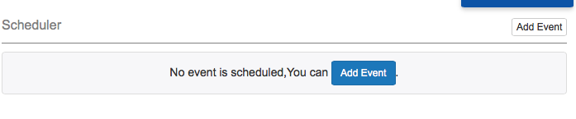
- You will then set the parameters for the event:
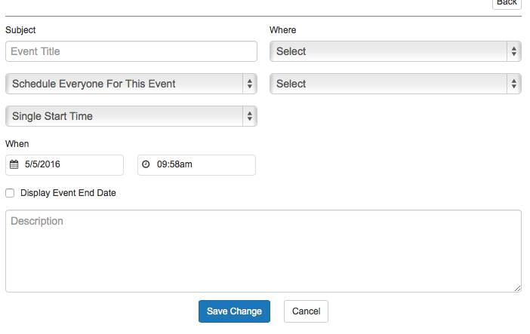
- Notice that you can schedule everyone that has signed up, or you can require signups. Many administrators will create a “Track and Field Day” as the league, and have the students register for the overall program, and then they will add different races, etc as the events and have the students sign up for which ones to compete in.
- You can also manually schedule participants for each event if you know how they will be broken down. You will want to specify gender for each event as well, or if it is an event where gender separation does not make a difference.

Entering Results for a Heat Scheduling Style Sport

- You will enter results directly from the event page by clicking “enter results”:
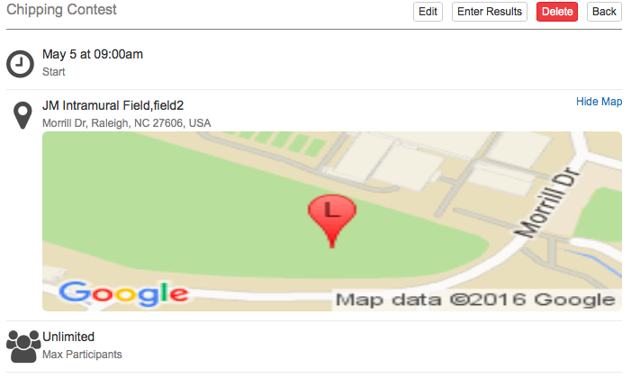

- You will also notice you can enter in that person’s time/score/position (whatever it is setup as) and also whether they “attended” the event for your participation statistics:
