Progressive Scheduling
Progressive Scheduling will set the schedule on a per game basis based on every team’s record. This type of scheduling tries to create even matchups, as it schedules teams of similar skill levels to play each other. However, this means the schedule must be adjusted on a per game basis.

- Create the league you wish to run progressive scheduling in. Then, go to League Settings, which can be found if you hover over the Admin icon on the right, and input the desired details for your league. The top of the League Settings screen will look like the picture below. 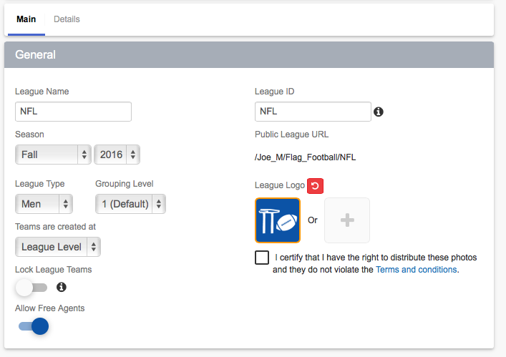
- Now that you’re on the League Settings page, set all of your desired details. In order to enable progressive scheduling, expand the Other Options tab, which will be towards the bottom of the page. Once you expand the Other Options tab, the following screen will appear. At this screen, be sure to adjust the Schedule Type to progressive scheduling. Then make sure to Save Changes at the bottom, which will create your league.
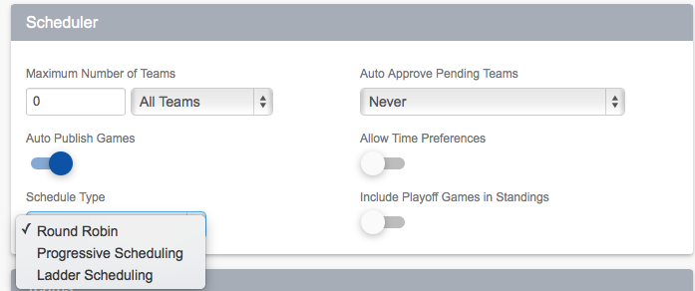

- Once your league is established and all of the teams have been approved its time to make the schedule. First, select the scheduler option that can be found under the Admin icon at the top of the screen. Then select the Setup Playing Times button and set your times. Then, return to the scheduler page and select Progressive Scheduling.
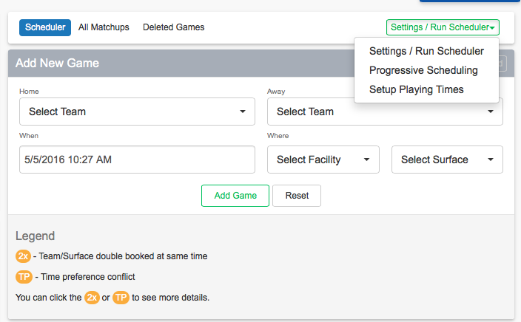

- Once you click the Progressive Scheduling button, the following page will appear:

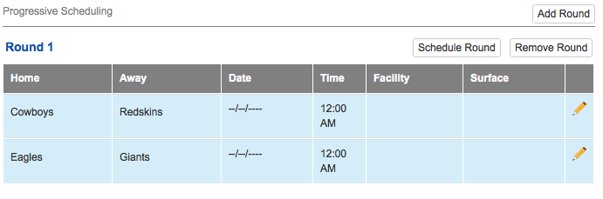

a. Notice how the matchups are set, but there is no date, time, or facility for the games. To add these, select Schedule Round, and then press Start. Now all of your games will have a date, time, facility, and surface. Once the first round of games has been played, input the scores. Now, to schedule the next rounds of games, just return to the Progressive Scheduling page and repeat the process. Do this for the duration of the regular season, and then run the playoffs in a traditional format. Congrats! You can now successfully run a Progressive Scheduling league.

