Custom Payment Plan

1. Under the Admin drop down menu select Payments Management.

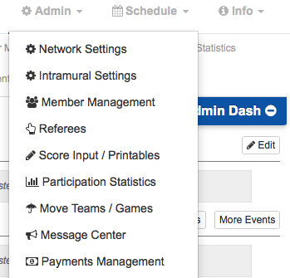

2. Now you should be on the Payments Management homepage, which looks like the picture below.
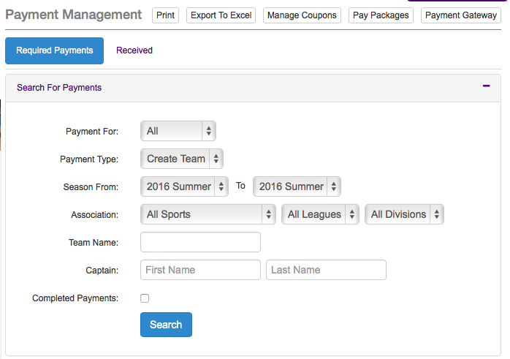
a. Select the Payment Gateway option that will be shown on the top right of the Payments Management screen.

G

3. Once at the Payment Gateway, you should be prompted to enter your merchant account information. After you enter your API Login ID and Transaction Key, make sure the Mode is set to test. Then press Save Setting.
a. Now that your merchant account information is saved, it’s crucial to run a test to ensure that the account is functional. To do so, first create a fake sports league to use as a test. Then, from the perspective of a user/student, attempt to join the league and pay. If everything up to this point has been done correctly, then the information will link up and the user/student will be admitted to the league. Once you know the link up is successful, return to the Payment Gateway and switch the Mode setting from test to live. Then press save setting. Congratulations! You just successfully set up your very own Custom Payment Plan.

