Generating Coupon Codes on IMLeagues

Coupon codes are a great tool if you take payment in the office and/or online. It is great for in-person payment for those administrators that do not want teams to be created before they pay. A captain will come to your office, submit his/her payment, and you will give them a coupon code that was randomly generated on IMLeagues that will allow them to register their team and bypass the “wall” of payment.

Coupon codes can also be used as incentives for captains to show up to captain’s meetings, show good sportsmanship, etc….you can give them a % off or a dollar amount off.

To Setup Coupon Codes, click into “payments management” by hovering over the admin icon from the school home page:
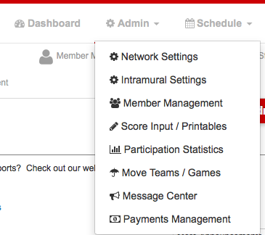

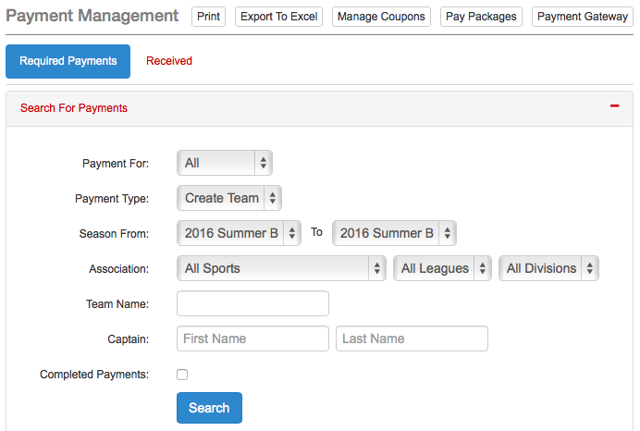
- You will then click “manage coupons” to access the coupon area.
- You can then search for codes, add codes, and randomly generate codes:
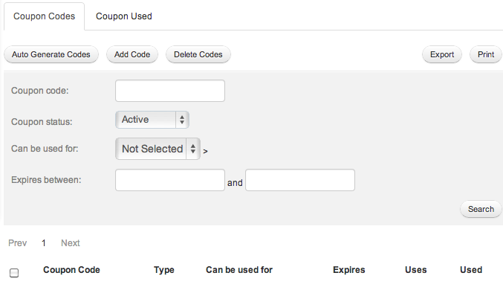
- We definitely recommend auto-generating codes, which will produce as many codes as you’d like, all unique, and all totally different so that students are unable to guess them. You can easily export a list of all the auto-generated codes as well.
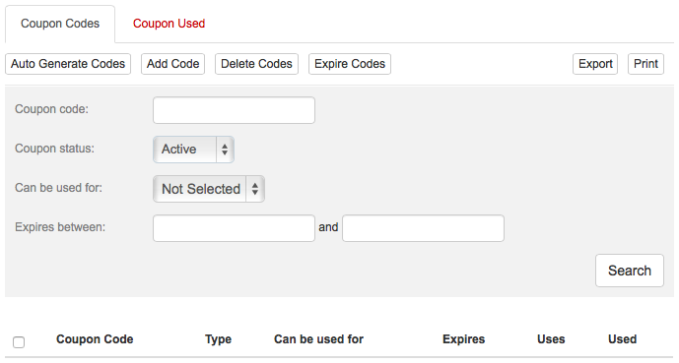
Here is the page the student will see when they attempt to register a team:
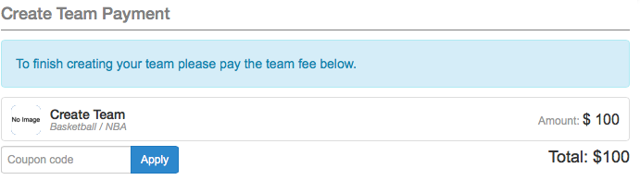
- They will be prompted to enter the coupon code, and they can then register their team.
- If you choose to not make it a barrier to pay, they can enter in the coupon code whenever they’d like to take the $ or % off:
