How To Setup Fitness Classes on IMLeagues

To setup a class, hover over the admin icon in the top white bar and click on “Add Class”:
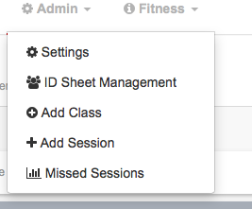
- On this page, you can set the name, color, duration, payment, location, and description for the class. This gets the class into the system, and you’ll never need to add the same class twice. The class serves as the “umbrella” that will hold all your active sessions on the calendar.
- Once you are done adding the class you must then add a session to it for it to show up on the calendar.

Follow the steps to setup the session:
- You can select the instructor, and then the session start time.
- You can then have that session “repeat” by clicking the “repeat” checkbox, and set it to repeat daily, weekly, or monthly.
- This allows you to setup any recurring sessions that occur at that time with one fell swoop.
- If you need to go back and add additional sessions at additional times, you can go back to the class page and add more sessions as needed.

If you have questions with setting up classes, simply refer to our “live support” on the bottom right side of every page on IMLeagues!

