How To Sign Up For a Fitness Class on IMLeagues

- If you are logged into your IMLeagues account, click on the fitness tab at the top of the page:

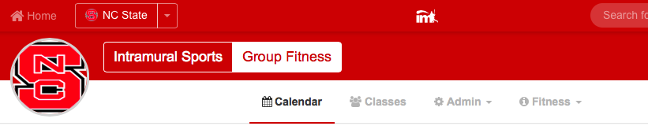

Note: You must create an account with your school and be logged in if you’d like to sign up for a fitness class.

- You can view the fitness calendar by day, week, and month. You can also select which classes you’d like to see by using the dropdown (See blue arrows):
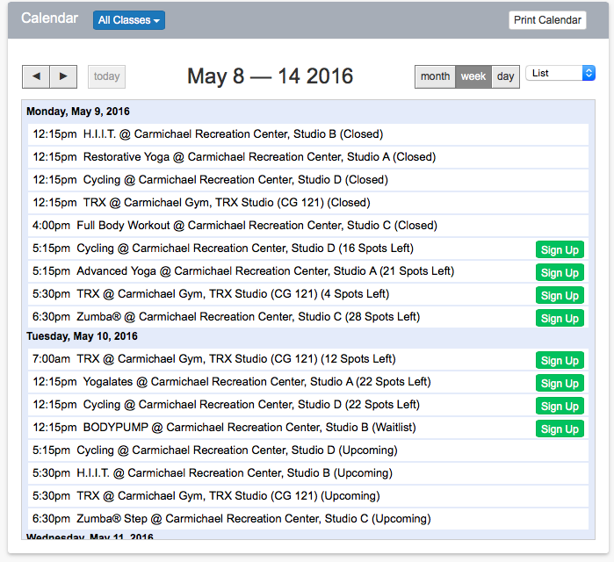
- To sign up, click on the session on the calendar, and then click the “sign-up” button:
