How To Upload an ID Sheet on IMLeagues

An ID Sheet is a great way to track eligibility by prompting your students to enter their Student ID # upon team registration, which will automatically cross-reference whatever ID# is uploaded for them on the ID Sheet.

Follow these instructions to Upload:

- Hover over the “Admin” icon on the school home page, and click “member management”:
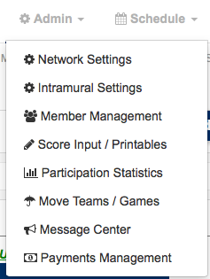
- Click on the “ID Sheet” tab and then “import”:
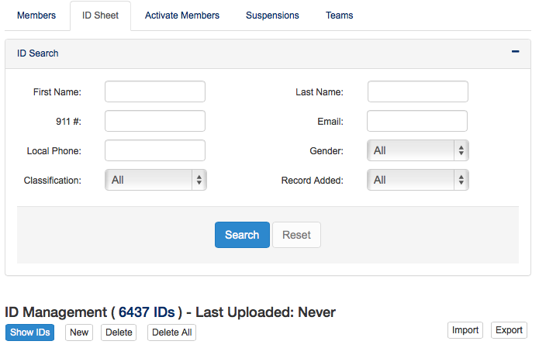
- When you click “import” you will see an example template of how the ID sheet should be uploaded. The only required fields are a unique identifier (Student ID#) and last name. BE SURE TO FOLLOW THE FORMAT!

Note: If you are uploading an updated ID Sheet throughout the semester, or a new one at the start of a new semester/school year, you will want to “replace” the existing one. If you are adding mass “additions” to the existing ID Sheet (such as a separate upload for graduate students), then you will “append” that ID Sheet (This basically just adds the new upload to the already existing records).

