Some participants won’t have a university given “portal” login, but will still be eligible to participate in intramurals. Follow these instructions to bypass the portal and join the school:

- Go to www.imleagues.com and click “Sign Up”. When creating an account, DO NOT select a school:
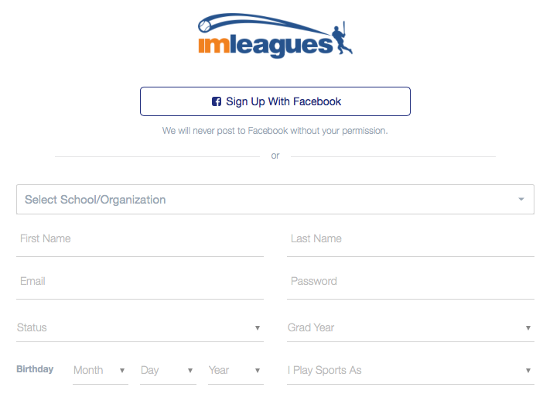
- When choosing an e-mail, you MUST use a NON-SCHOOL EMAIL. When you are done registering your account, and you’ve activated it through your email, log in and click “create/join school” at the top.
- Type the name of your school in the space provided. When it pulls up, click “join school”
- You will receive an error message that states you cannot automatically join the network, but that you can send a request to be approved by an administrator at your school. Click “Send Request”:
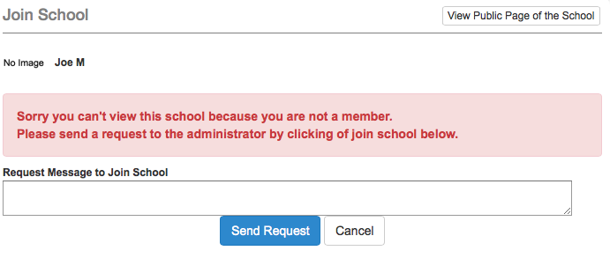
Note: You just have to wait for an administrator to approve your request to join the school and then you’ll be ready to sign up for intramural sports!

