How To Setup Club Sports

- To turn on the club sports component of IMLeagues, you will need to go into the network settings and on the main tab you will see the enable function in the General Settings box:

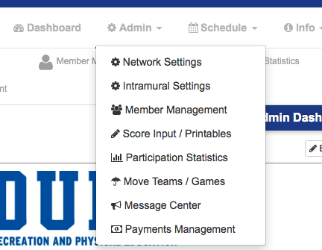
- You will then scroll towards the bottom of the page and save your changes:
- You will then see the “Club” tab at the top of the page:

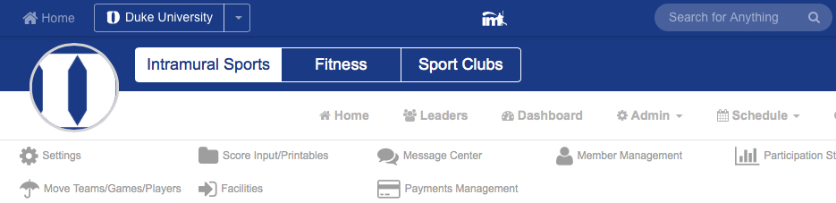
- You will first want to make sure that you are using the “sport” view, which can be set by hovering over the “admin” icon and click “settings”.
- Then, you are going to add a brand new “sport” for each and every club team you have. When you create a “club” sport, also add the league to it as well.
- Important: Again, each club will have its very own sport and league.
- Once you are done adding the sport and league for you first club, go ahead and create the team as well using the “register/signup” option. You will be considered the “captain” of the club. Once you are done creating the team, use the “invite players” option from the club team page to send out email invites to any club officers that will be overseeing roster management for that club. Do this for the rest of the club teams that you’ve setup.
- Once one person has accepted an invite, you may go to the roster page, remove yourself from the team, and set the other person as the “captain”.

SUPER IMPORTANT: Once you’ve setup all your club sports/leagues/teams, go back into the “settings” on the club home page (admin>>settings), and change the view from “sport” view to “team” view. This makes finding teams SO much easier for participants, as it lays out the links to the team pages on the clubs home page.

The main feature of our sport club component has been form tracking so that you can keep track of the status of all the forms your participants have submitted.

- To access the forms section, hover over the admin icon, and click “forms”:
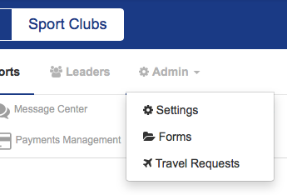
- You will then be taken to the back end section of the forms you’ve created:
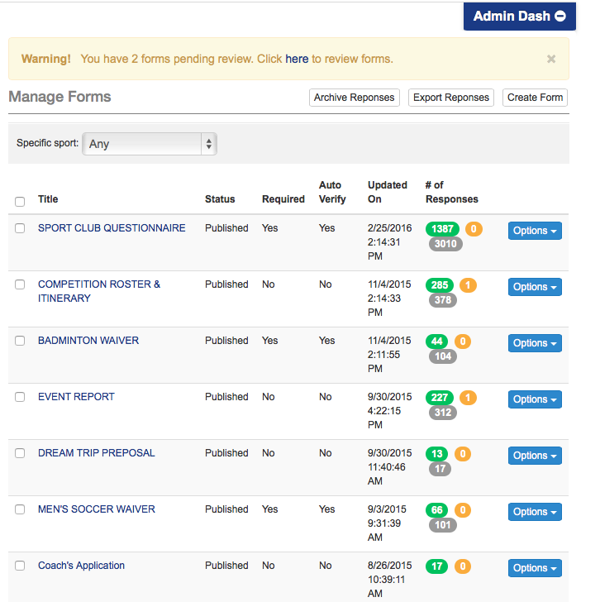
- We’ve tried to make data collecting as easy as possible for you, and you can mass export the responses of forms to excel right from the main forms page. You can also click on the “number” where it says “# of responses” to see individual responses to forms and review/print/export all the responses for that specific form.

Creating Forms on IMLeagues

- Click the “create form” button at the top right of the page. You will then see this page:
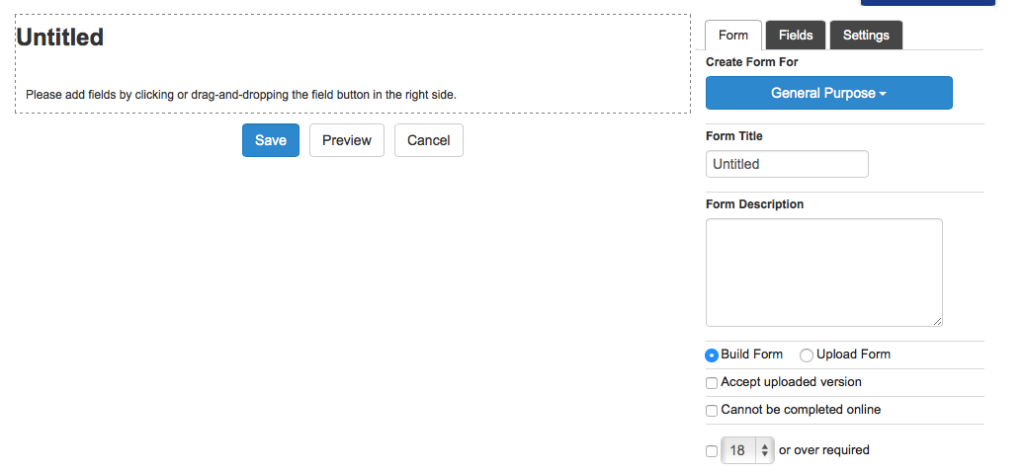
- You are basically setting the form up from scratch using our widgets located on the “fields” tab. Be sure to fill out everything on the “form” tab first. Then, you can basically capture any information necessary when you click on the fields tab:
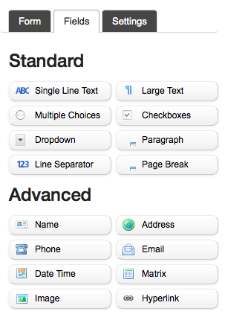
- All you have to do is click the widget you’d like to use and it will appear.
- For example, let’s say you needed a student’s insurance company and insurance policy #, you can use the “single line text” widget by clicking on it and labeling it as such:

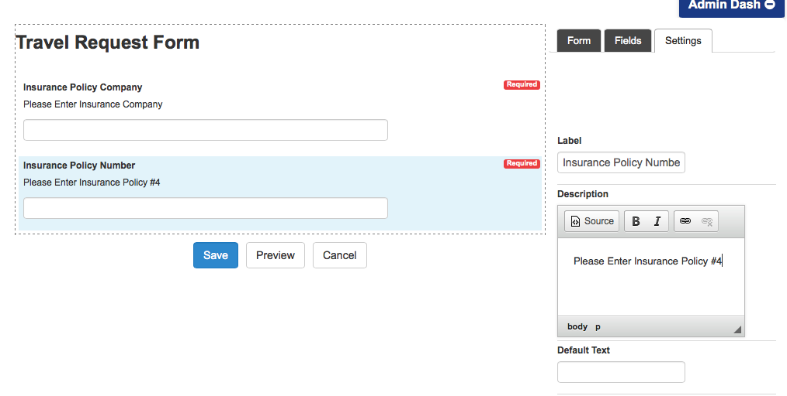
- The “Settings” tab will pop up and you can label it however you want. In this instance, I clicked the green plus sign to duplicate the widget so I could separately collect the insurance company and then the policy number.
- You will notice that you can use multiple choice responses, dropdowns, checkboxes, address for emergency contact info, dates (for departure/return), names (for a travel roster), etc.

Each Club Sport will have it’s own team page, which is great for interested students to get an overall feel for the club, and for officers to send emails to their team using the “more announcements” button.
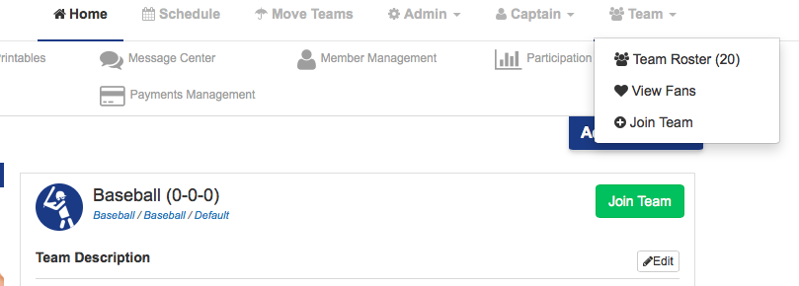
Note: You can also easily see the status of form responses by accessing the roster page.
The roster page for each club sport is a great way to see the status of everyone’s responses to required forms: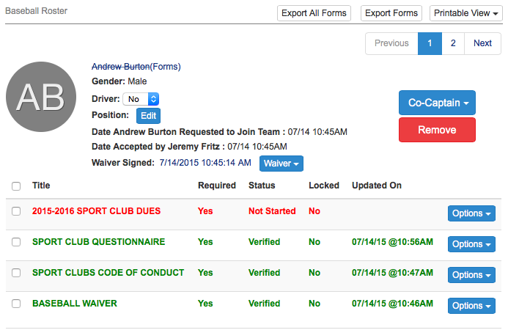
- You will notice that a person’s name will be crossed out until all of their required forms have been submitted. Any form that has not been submitted/verified will be highlighted in red, and any form that has been verified will be highlighted in green, as shown below:
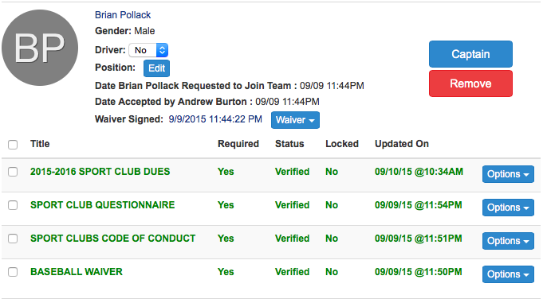
- You can also click on the box on the right hand side to see the responses that each person has submitted.
- You can also label someone as a driver for that club, as well as whatever position they hold with the club (President, Vice President, etc.)
- You can also get a “printable view” of the roster and easily see who’s eligible.

Other Club Sport Tidbits

- When you send an announcement from the club home page, it only sends out to your club participants
- You can send messages using the message center, and you can select the “club” filter to only reach out to your club teams
- There is a Club Sport specific tab in participation statistics so you can grab your participation numbers
- If you use IMLeagues for club sports and intramurals, and you have limitations for club sport members joining intramural leagues, you can automatically set this up in the league settings for intramurals:
- Any time a form has been submitted, you will receive a red notification at the top of the page by the globe. You can review, accept/reject the form submission:
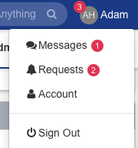

- You will schedule club sports the same way as intramurals, by clicking onto the league link (see blue arrow), then hovering over the admin icon, and clicking into the scheduler. You will want to manually add events and you will notice that you can label them as a practice/scrimmage/event, and you can also simply “write-in” whatever you’d like:

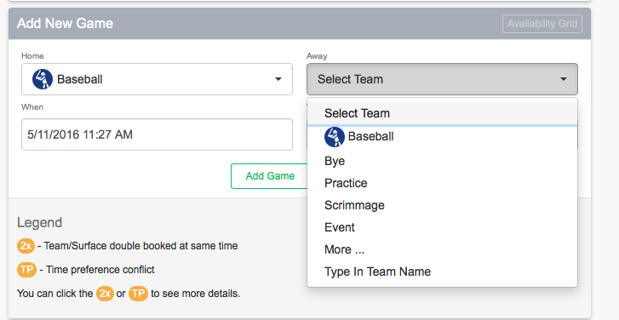

- You can provide your students with the publically viewable link to your Club Sports home page by hovering over the admin icon, clicking into the “settings”, and using the “Public Club URL”.

Student View: Form Submission

- Whenever a student has been accepted onto a club team, he/she will see this prompt at the top of the club sport home page until all required forms have been submitted:
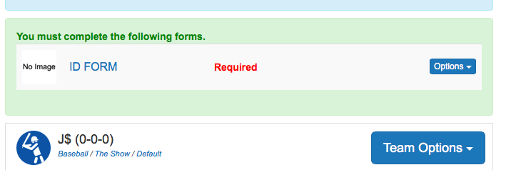

Students will also see a prompt on their home page when they first login if they have required forms to submit:
Students can also access all forms from the “my forms” area on their user home page.

