Setting Up Time Preference Scheduling

Setting up time preferences allows your captains to mark availability to play. There are a few steps needed to set this up, and it’s best to have them setup BEFORE registration opens.

When you are creating your league, you will see the area to setup time preferences. If you’ve already setup your league, you can turn them on by going into the league settings:

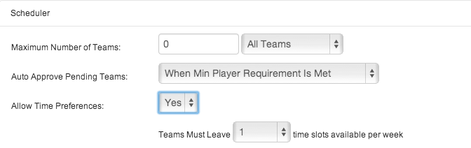

A brief explanation on Time Preference Scheduling:

- Upon registering their team, captains will mark availability based on the time slots you’ve given them.
- After captains have marked availability and you are ready to make a schedule, the scheduler will take every team’s time preferences into account and schedule around those preferences.

When you turn them on, you will be prompted to enter the total number of time slots that teams need to leave available per week. This number is based on the time slots you plan on playing the league. For example, if you are playing games Monday and Wednesdays from 6-9PM (with games starting each hour), that’s a total of 3 time slots in a night, multiplied by 2 nights a week for a total of 6 time slots. The general rule of thumb is that captains need to leave at least half of those time slots available. Therefore, you would select “3” for the number of times that teams need to leave available.

Note: Even if you are playing on multiple surfaces at the same time, those still only counts as one overall time slot.

Notice that when you turn them on and save your changes, you will see this prompt at the top of the screen:

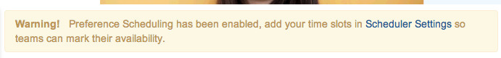
- The next step is to click on “Scheduler Settings” so you can enter in time slots in order for captains to mark availability: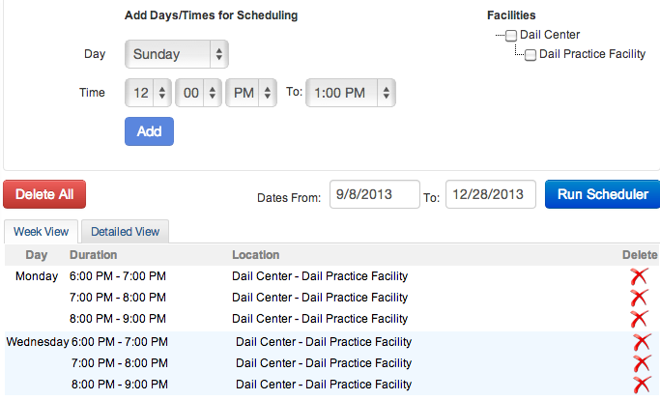
- Once you’ve added time slots, your captains are ready to mark availability.
Setting Time Preferences From the Student Side

- The team captain will be prompted to mark availability upon the completion of team registration, as shown by this screen: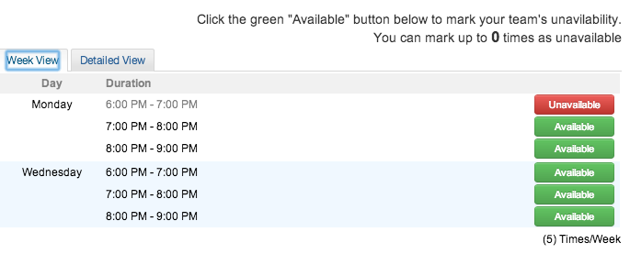
- Every team is considered available at all times. To mark a time each week as unavailable, simply click on the green “available” button.
- Notice that a captain can click on the “detailed view” and mark an exact date and time as unavailable. This is good when teams are not necessarily unavailable EVERY Wednesday night at 7PM, but for a specific Wednesday night at 7PM later on in the season:
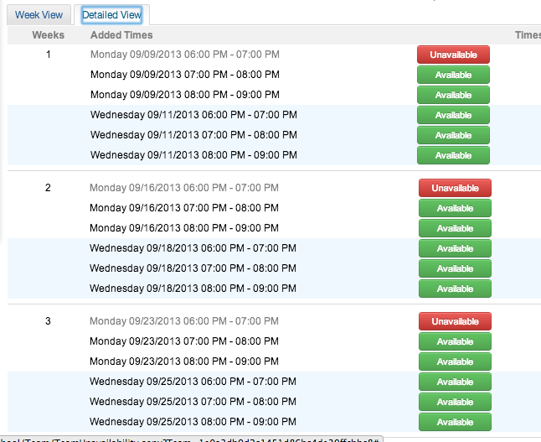

If a captain needs to adjust time preferences, he/she can do so at anytime by clicking on the team page and hovering over the “captain” icon in the white box and clicking on “time preferences”:

