***Pay Packages***

1. Log in to your IMLeagues account

2. Find your school’s tab along the top bar and click.

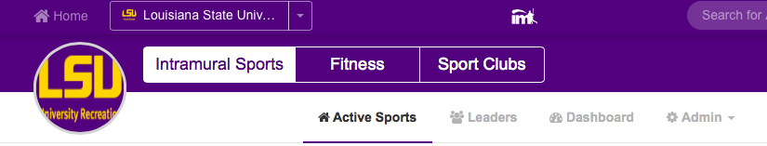

3. How to set-up Pay Packages.

* Hover over the “Admin” box and click on “**Payments Management**” on the top white bar (see red arrow below!) and you will be taken to your Payments Management page.

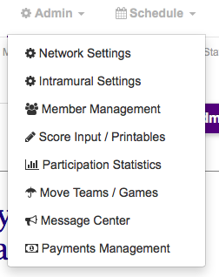

* From there click on the “Pay Packages” button in the top right corner

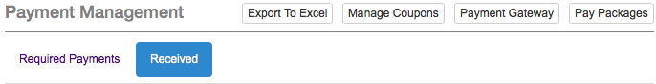

* You will now be brought to the screen where you can search for different Pay Packages you have created. To create a Pay Package click the “Add Pay Packages” button.

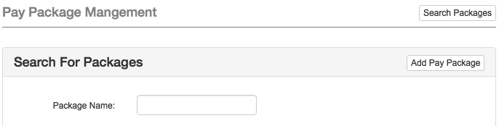

Now we will go through each aspect of the **Pay Packages** (See Blue Arrow!) and what they mean:

1. **Package Name:** Choice of what you want the package to be called (ex: Spring Fitness Pass)
2. **Cost:** How much to charge for the package
3. **Valid From**: When the Package will be able to be used by participants
4. **Number of Uses**:How many times the participants will be able to participate with the purchase of the pay package. (Ex: If the pay package is good for 10 fitness classes select 10,if it is good for the entire semester select Unlimited.)
5. **Can be used for**: Designate what the pay package is used for.
6. **Can be purchased by:** Select who can purchase the package
7. **Select Online Payment:** Whether or not the pay package can be used to pay online

*Click Save Changes and now you have completed Adding a Pay Package!*

4. Now we have to Select the Sports/ Fitness Classes that will use the Pay Package that you just created.

* Click on the tab at the Top of your screen that you want to add the Pay Package to (For this example we will add the Pay Package to a Fitness Class).
* If you have already created a class we must now choose that class to add the Pay Package to so click the “Classes” tab and click on the class you want to add the Pay Package to. (Note: If you are applying the Pay Package to classes that have not yet been created, you will add the Pay Package when creating the class.)

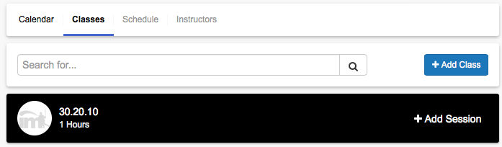

* Click on the blue “Options” button in the top right corner and then click “Edit Class.”
* Scroll down until you see the “Require Payments” tab and check the box. More options should open up after you click the box.

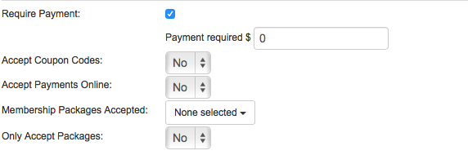

* Fill in the Payment Required (the cost of the Pay Package) and fill in the other options
* Click on the Membership Packages Accepted and select the Pay Package you want to apply.

*Click Save Changes and now you have completed Adding a Pay Package to a class!*